Simple DNA-Chromatin Interaction Model and its biological Implications
Dong hyun Kim
Department of Physics, MIT
Eukaryotic cells can pack long DNA chains into a small volume by wrapping it onto nucleosomes. This DNA-nucleosome interaction not only serves as a DNA protection mechanism, but also, in terms of gene regulation, serves as a sensitive gene expression control mechanism. Here we derive and analyze a simple mechanical DNA-chromatin interaction model and discuss its biological implications. We also explore other models describing regulatory effect of nucleosomes.

Introduction
Eukaryotic cells contain a very large quantity of DNA. For instance, chromosome 1 of human cell, which is the largest among the 23, is approximately 220 million base pairs long, thousand-fold larger than that of typical bacteria. If it were stretched, it would be long enough to wrap the cell nucleus thousands of times. Thus it is easy to imagine that the DNA polymer of eukaryotic cells have high risk of damage. However, this risk is dramatically reduced by adopting a compact packaging mechanism. Eukaryotic genomic DNA helices are densely packed with nucleosome which is a fundamental packing unit. It is made up of eight histone core proteins (histone octamer, H2A, H2B, H3, H4, two of each) and 147 base pair (bp) DNA stretch wraps around it. This nucleosome exists periodically in the chromosomal DNA with ~200 bp long linker DNA in between. These nucleosomes can go under a high order compaction, creating a chromatin structure. This compact packaging mechanism allows eukaryotic DNA to fit in the nucleus and reduces the risk of their damage.
However, a question arises. Would the genes that are located at the DNA stretch which are wrapped to the nucleosome be accessible to various molecular machineries? It turns out that 75-90% of genomic DNA is wrapped in nucleosomes. Will they ever be expressed? In order for a gene to be activated, the nucleosome at that position should somehow be displaced so that the transcription factor (TF) and RNA polymerase can bind to the DNA. One model to explain nucleosome displacement during transcription recruits an initial ‘activator’ or ‘ATP dependent nucleosome remodeling factor’ protein binds to its binding site which is located on a linker DNA, which then directly disassembles the nucleosomes. But the underlying mechanism, such as ‘how they know which nucleosome to remodel, is poorly understood and experimental data suggest that they may disassemble but remain bound to DNA and the access of proteins to buried nucleosomal DNA target sites doesn’t occur via nucleosome translocation. An alternative model assumes that the polymerase pulls the local DNA stretch apart from the histone octamer as it slides along. Recent findings from single molecule imaging experiments suggest that nucleosomal DNA wraps and unwraps nucleosomes randomly due to thermal fluctuations.

Specialized DNA packaging scheme is expected from typical biological length scales
Assume the typical length of DNA L in a eukaryotic cell to be 1m. From single molecule studies, persistence length of dsDNA is known to be around 50nm. Then it is possible to calculate the radius of gyration of the dsDNA. ,
However, this is much larger than the size of a typical nucleus of eukaryotic cell which is 1~10 and it is obvious that these cells have a special way to tightly pack the long DNA chain into the small nucleus.

Random wrapping-unwrapping of nucleosomal DNA allows access of transcriptional machinery
Recently, J. Widom reported that nucleosomes undergo stochastic conformational fluctuations such that a stretch of the nucleosomal DNA repeatedly wrap and unwrap the nucleosome and experimentally measured the rate of the process using fluorescence resonance energy transfer(FRET). The life time of wrapped state (1/k12) was ~250ms and that of unwrapped state (1/k21) was ~10-50ms (see Fig. 1). This spontaneous unwrapping, although the rate is rapid, allows protein to access the buried binding sites.
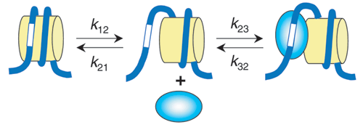
Figure 1. Spontaneous site exposure mechanism. J. Widom et al. Nature Struct. Mol. Bio. 2005
In the following year, his group revealed the underlying mechanism of selective nucleosome-DNA binding by showing the existence of binding motifs that recur periodically at the DNA helix. These include ~10bp periodic AA/TT/TA dinucleotides out of phase with ~10bp periodic GC dinucleotides. These are the binding sites which spontaneously and rapidly open and close- the ensemble average of this reaction can then be described with rate constant k12 and k21. Also, during the unwrapped state which has ~10-50ms lifetime, TFs can bind or unbind to the DNA target site with rate k23 and k32 respectively.
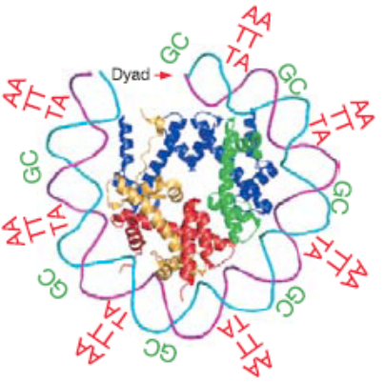
Figure 2. Nucleosome-DNA binding motifs require peridodic AA/TT/TA dinucleotides. J. Widom et al. Nature 2006

Two state (half open or closed) model
Inspired by J. Widom’s observation, we can describe statistical ensemble of this as a two state (half open or closed) system using Boltzmann distribution and assuming that DNA can unwrap only from one end, such that
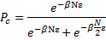
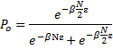
where ε(< 0) is the binding energy of a single “sticky” dinucleotide and the nucleosome, N is the total number of sticky sites in a nucleosomal DNA stretch, is the probability of a dinucleotide to be in closed (N sticky sites are bound), and is the probability to be in half open state ( sticky sites open). Based on the above definition, we can calculate the binding energy ε by assuming the following numerical data:
- There are approximately nucleosome sticky binding site (dinucleotide) within the 147bp DNA stretch
- The 147bp DNA stretch is tightly bound to the nucleosome such that unwrapping has to start from the sticky site located at either of the end, unbinding one sticky site at a time in a row
- Typical equilibrium constants describing DNA accessibility are for sites located a short distance inside the nucleosome, decreasing to for sites located near the middle of the nucleosome(ref. vii)
- Each sticky dinucleotide site doesn’t interact with neighboring sticky sites.
From (3), roughly,
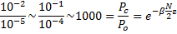
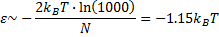
which is roughly consistent with the idea that thermal kicks can open and close nucleosomal DNAs. However, this model is far too simplified by assuming two possible states and it also did not include the energy required to bend dsDNA which has a persistence length larger than the size of a nucleosome spool.

Cooperative model for random wrapping and unwrapping of nucleosomal DNA
We can come up with a more sophisticated model by including more physical details of the system. For instance, nucleosomes can be thought of as a cylindrical spool of radius . This is about one-tenth of DNA persistence length and this means there is an energy cost for DNA wrapping.
Thus, random spontaneous wrapping and unwrapping of the nucleosomal DNA can be modeled by assuming that DNA strands wind or unwind one dinucleotide(AA, TT or TA) unit at a time randomly in a spiral fashion without any loophole. Each “sticky” dinucleotide sites can be in either bound or unbound state and since winding DNA strand to a spool requires energy because of its bending rigidity, we can write the canonical partition function as
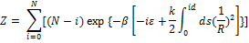
where is the number of bound state sticky sites, is the total number of sticky sites on a nucleosomal DNA stretch, is the binding energy of a sticky site, is the bending rigidity of DNA, is the distance between sticky sites, and is the radius of the nucleosome assuming that it has a cylindrical shape. The weighting factor is included in the sum since there are possible ways to stick consecutive sticky sites of a nucleosomal DNA stretch with total sticky sites. Here we neglected electrostatic repulsions between negative charges of the DNA backbone. After some algebra, we get
where .
From this partition function, we can calculate the mean number of bound state sticky sites and its fluctuation as a function of which is the difference between binding energy and bending energy of a DNA strand of length between adjacent sticky sites.
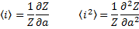

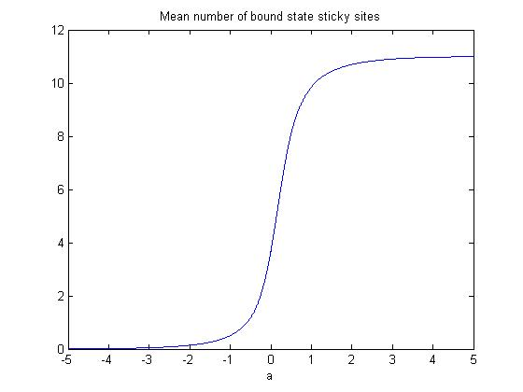
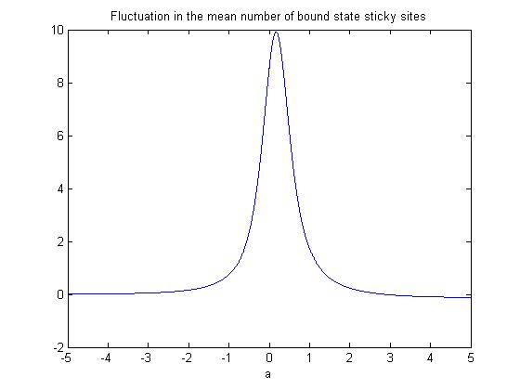
Figure 3. Upper plot - mean number of bound state sticky sites / Lower plot – fluctuation
We can estimate the sticky site binding energy by choosing which gives significant amount of fluctuation for , assuming that the experimentally observed thermal wrapping and unwrapping of nucleosomal DNA needs to be large enough so that transcription factors can access the buried DNA promoter sequences. Plugging in the typical known values (assuming that there are approximately nucleosome sticky binding sites per nucleosomal DNA stretch),
we get . Therefore, the binding energy of each nucleotide from a single sticky site is which is in the same order of net free energy cost of breaking a single H-bond in water. These values also agree with the fact that rapid opening and closing is due to thermal agitation.
One interesting property of this model is that the mean number of bound state sticky sites is a sigmoidal function of the difference between binding energy and bending energy of a DNA strand of length between adjacent sticky sites, . This is due to competition between the two conformations of nucleosomal DNA – bound and bent, or unbound and unbent—and there exists a critical point at which the sticky site binding energy and corresponding bending energy are roughly equal. Since the width of the fluctuation peak is , random thermal agitation can open and close the nucleosomal DNA rapidly in a switch-like manner.

Biological consequences
Nature seems to take advantage of such cooperative wrapping-unwrapping property. As a part of gene regulation, histones are acetylated and deacetylated on the surface of the nucleosome core. Histone acetylation brings in a negative charge to neutralize the positive charge on the nucleosome which effectively decreases the coulomb interaction with negatively charged DNA and loosens the wrapped nucleosomal DNA opening up the promoter region . To gain fitness, an organism has to be very sensitive to the environment and transcribe genes in a sensitive way even though most of them are wrapped to nucleosomes(ref viii). In the model above, sensitive transitions can be achieved by slightly changing the value of . For the case where “ground state” value of is , nucleosomal DNAs can quickly switch between the two states by simply lowering (by raising via acetylation) , or raising it back to (by lowering via deacetylation). Change of larger than few will be sufficient. See figure 3. By modifiying histones, a cell can efficiently regulate many “nucleosomal” genes at the same time. It turns out that most of the genes are “nucleosomal”. See figure 4 and 5.
Chromatin modification seems to have a lot of implications in variety of biological functions. It is obvious that the presence of nucleosome can repress whatever gene’s TF binding site located within. It seems that eukaryotic gene networks’ dynamic range is fundamentally limited by nucleosome in virtue of keeping the genome compact and secured. However, recent studies showed that in some cases nucleosomes are actually used to tailor the gene expression into a more sophisticated fashion, so that a network can efficiently respond to the changing environment. For example, in S. cerevisiae phosphate response(PHO) pathway, nucleosomes mainly function to decouple the threshold of induction from dynamic range- the gene expression becomes more dynamic in different environmental phosphate levels. This diversity may be crucial for gaining evolutionary fitness. Another interesting example of gene-nucleosome interaction is in yeast S. cerevisiae SUC2 pathway. SUC2 encodes an enzyme called ‘invertase’ which hydrolyzes sucrose into glucose and fructose. SUC2 expression is regulated by glucose concentration of the environment (high glucose represses SUC2 and vice versa) and people have been speculating that when there is low glucose, Swi/Snf activation complex protein de-stables the nucleosome covering the promoter, helping TFs to bind. Chromatin modification has also been implicated in synaptic plasticity and learning behavior. It is known that increased histone-tail acetylation induced by inhibitors of histone deacetylases (HDACis) facilitates learning and memory in mice.

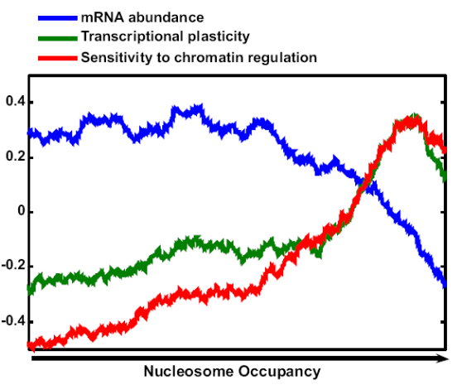
Figure 4. Correlation between nucleosome occupancy and transcription regualtion (Barkai N. et al. Genome Research 2008)
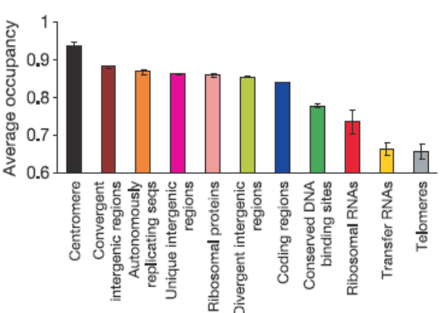
Figure 5. Average nucleosome occupancies for different types of genomic regions (Widom, J. et al. Nature 2006)
Another possible prediction from this model is noisy gene expression. In 2002, Michael Elowitz and colleagues showed that the source of noise can be extrinsic, in which the cellular capacity to produce proteins and the regulatory systems fluctuate over time, or intrinsic, which arises due to stochastic variations in the transcription and translation events of the gene. They measured the relative level of intrinsic and extrinsic noise by measuring the levels of two fluorescent proteins expressed by identical promoters. Later, more careful mRNA level noise experiments were done in isogenic mammalian cells. In this work, there were massive variations in the number of mRNA molecules present in each cell. The variations were due to short but intense transcriptional bursts which began when the gene made transition from an inactive to an active state and ended when they transitioned back to the inactive state. The most likely source of these bursts was random chromatin remodeling -- when two reporter genes were located at distant regions of the genome, they bursted independently, while when they were located near each other, they bursted together. In the context of our cooperative model discussed above, we expect a large variation in the number of bound sticky dinucleotide sites (degree of openness) of during transition between and which is equivalent to histone remodeling. Thus the model shows that bursty gene transcription can be caused by transition between two competing states of the nucleosomal DNAs (either bound and bent or unbound and loose).

Ultrasensitive gene regulation can be achieved via nucleosome modification
There have been a lot of efforts to explain or create ultrasensitive responses of gene regulation pathways to a seemingly weak upstream signal near threshold. For instance, Uri Alon introduced the concept of ‘network motif’ which is an analogue of ‘logic gates’ in electronics and he showed that a genetic negative feedback loop could speed the response times of transcription networks. Also, Wendell Lim has engineered synthetic signalling proteins with ultrasensitive input and output. However, the observations which revealed the fact that nucleosome binding can be exploited by gene networks have opened a new era for system biologists. People have started trying to understand eukaryotic transcription in a bigger picture including the regulatory effect of nucleosomes.
It is known that transcription factors (TFs) can recruit enzymes such as histone acetyltransferase, deacetylases, methyltrasferases, demethylases to the promoter and change the modification state of nearby nucleosomes. This itself is a linear mechanism so it cannot generate sensitive response, however, it has been proposed that nucleosome modifications involve feed-forward loop where nucleosomes carrying a particular modification also recruit enzymes capable of maintaining the same modification state among neighbouring nucleosomes. Ian Dodd recently introduced a model of positive feedback in nucleosome modification.

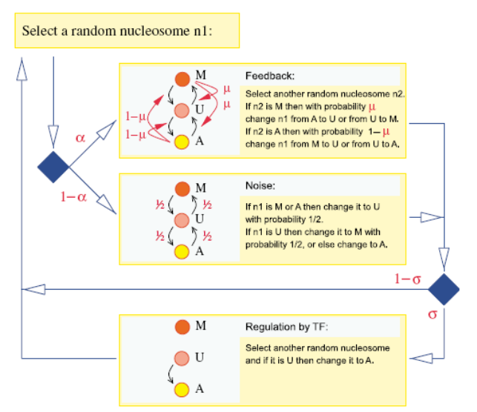
Figure 6. Model for positive feedbacks in nucleosome modifications, with regulation by a TF that recruits a histone-modifying enzyme. (ref. xvi)

The model (see figure 6.) is based on the following assumptions:
- Only three nucleosome modified states are considered: unmodified(U), methylated(M), and acetylated(A).
- Nucleosomes are actively interconverted by recruited modifying and demodifying enzymes. Transitions can only occur between A and U or U and M (No direct transition between A and M). The relevant parameter here is µ(). When µ=0.5, the conversion is perfectly balanced.
- Nucleosomes can also be randomly interconverted in a recruitment-independent manner - “noise” in the system
- Relative strength of the feedback and the noise is parametrized by α.
- There is a TF which binds to a DNA within a nucleosome patch and recruits histone-modifying enzyme which further facilitates U→ A modification. The strength of this TF stimulated reaction is σ, and it will be proportional to the TF activity.
The model then could be simulated in a stochastic manner in time steps in a system of N nucleosomes. The result shows bistability having either high A(low M) or low M(high A), depending on σ and and the transition between the two states is ultrasensitive (high Hill coefficient) to TF activity(σ) near threshold at high N(large number of nucleosomes)(see figure 10). Since high A state corresponds to high promoter activity, it can be concluded that the feedforward loop of nucleosome modification indeed generate an ultrasensitive response to TFs.
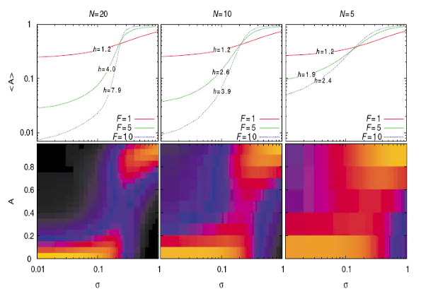
Figure 7. Simulation of the model described in fig 9. ( iteration) (ref. xvi)
This model also agrees with the observed rapid evolution. A system consisting of indirectly interacting TF should be less constrained to evolution than those which require direct contact of TFs.

Conclusion
Nucleosomes are not only simply a physical structure necessary for packaging large eukaryotic genome but also a crucial component in regulating gene expression. Rapid spontaneous wrapping- unwrapping enable transcription factors to gain access to their binding sites and we can build a simple mechanical model that can predict cooperative nucleosome-DNA interaction enables us to explain many of the known biological phenomena. The overall interplay of nucleosomes and transcription factors exhibits a rich gene expression pattern which might endow fitness to an organism in the context of evolution.

Reference

Molecular Biology of the Cell 3rd, Bruce Alberts, et al.
Richmond, T.J. & Davey, C.A. The structure of DNA in the nucleosome core, Nature 423, 145-150(2003)
Khorasanizadeh, S. The nucleosome: from genomic organization to genomic regulation. Cell 116, 259-272(2004)
J. Widom et al. Spontaneous access of proteins to buried nucleosomal DNA target sites occurs via a mechanism that is distinct from nucleosome translocation. Molecular and Cellular Biology, DOI: 10.1128/MCB.22.20.7147–7157.2002
K.E. van Holde et al., J. Biol. Chem. 267:2837-2840
Polach, K.J. & Widom J. Mechanism of protein access to specific DNA sequences in chromatin: a dynamic equilibrium model for gene regulation. J. Mol. Biol. 254, 130-149(1995)
Widom, J. Rapid spontaneous accessibility of nuclesomal DNA. Nature Struct. Mol. Biol. 2005
Widom, J. et al. A genomic code for nucleosome positioning. Nature 442, 772-778(2006)
Philip Nelson, Biological Physics, Chapter 7.5. Freeman 2008
http://en.wikipedia.org/wiki/Histone_acetylation_and_deacetylation
O’Shea EK et al., Chromatin decouples promoter threshold from dynamic range, Nature 2008
Yan Bu et al. Identification of cis-acting elements in the SUC2 promoter of S. cerevisiae required for activation of transcription, Nucleic Acids Research 1998
Guan, Z. et al. Integration of long-term-memory-related synaptic plasticity involves bidirectional regulation of gene expression and chromatin structure. Cell (2002).
Elowitz et al. Stochastic gene expression in a single cell. Science. 2002
A. Raj et al. Stochastic mRNA synthesis in mammalian cells. PLOS Biology. 2006
Alon, U. Negative autoregulation speeds the response times of transcription networks, J. Mol. Biol, 323:785-93, 2002
Lim, W., et al., Using engineered scaffold interactions to reshape MAP kinase pathway signaling dynamics, Science 319, 1539-43 (2008)
Bernstein, B., Signaling network model of chromatin, Cell vol. 111, 771-778 (2002)
Dodd, I. Ultrasensitive gene regulation by positive feedback loops in nucleosome modification, Mol. Sys. Bio. 4:182, 2008

