The Undergraduate Late Add Drop form allows you to electronically review and act on student petitions to change their registrations after the deadlines have passed. Instructors and Advisors are asked to support or decline to support petitions as well as provide a statement of support or lack thereof that elaborates on the student’s circumstances.
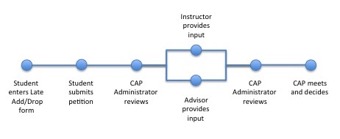
There are two pages you will use.
- My Forms - locate your form for viewing and editing
- Undergraduate Late Add Drop Petition – support or do not support proposed changes by students
The My Forms Page (Advisor & Instructor)
On this page you can access forms for which you have previously rendered a decision and/or advisee forms which await instructor approval.
Click Settings in the menu bar to change email notification schedule.
The Action Required list shows the type of form, the student name, ID and Kerberos, as well as the status, actions required by students, instructors and advisors, and the date and time submitted. Click the Form Name (e.g., Undergraduate Late Add Drop) to open a student’s form to the Undergraduate Late Add Drop page.

The Undergraduate Late Add Drop Page
The Student Information area at the top left of the form is the same for Instructors and Advisors. It displays student information and the student’s proposed registration changes. Below the proposed changes you’ll find the Student Statement that explains this late registration change request.
Click a name in blue to write an email to that person.
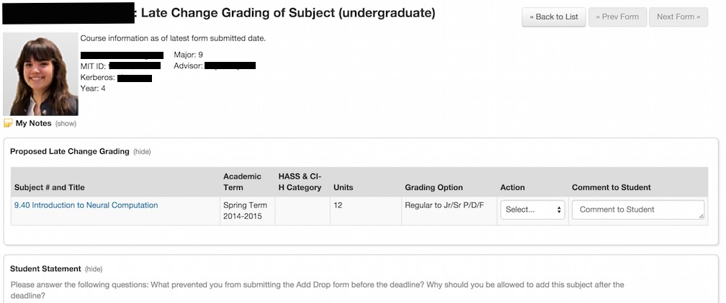

Select an Action
Choose an Action from the drop-down list:
- Support: You support the student’s petition.
- Do Not Support: You do not support the student’s petition.
- Consult: You would like the student to contact you before you’re ready to make a decision.
You may also add a comment to the student.
If you have chosen to Consult with the student, skip to Save/Submit below. Otherwise continue to Support Statement.

Support Statement
Once you have made a Support or Do Not Support decision, you are required to enter a statement about your support of the student’s petition. This should indicate the strength of that support and provide more information on the student’s commitment and progress. Enter it in the appropriate section for Instructor Support Statement or Advisor Support Statement.
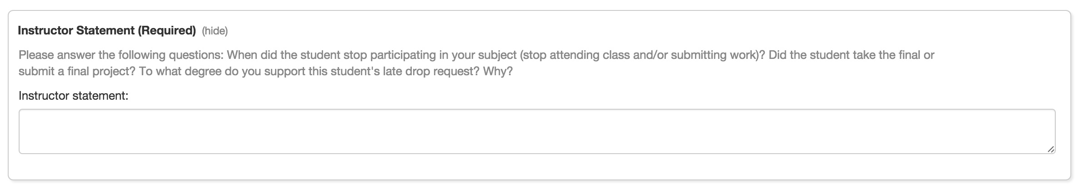
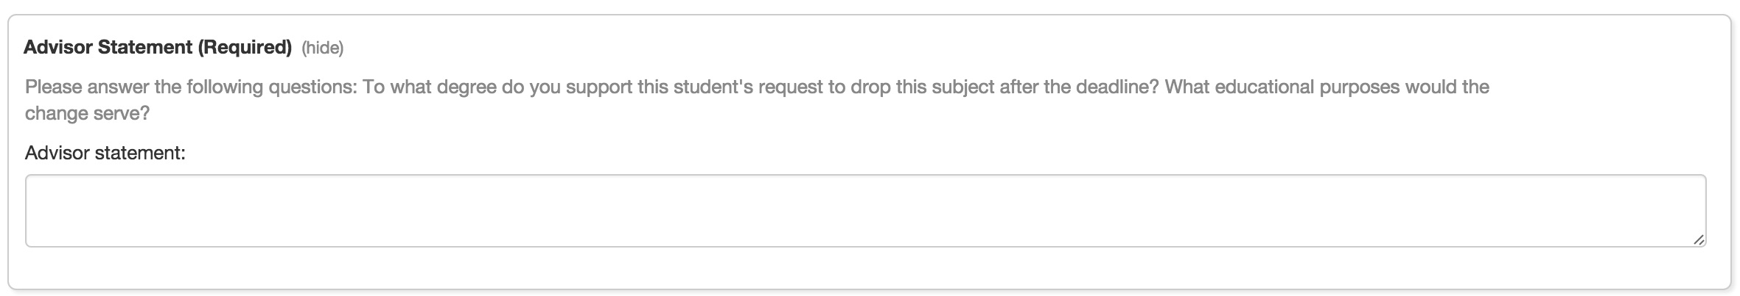

Save/Submit
At the bottom of the page, click Submit to record your decision. Note that you may edit your decision until the CAP Administrator has taken an action.
If you are not ready to Submit, you can click Save for Later. The information entered on the petition will be saved and the petition will continue to be listed on your My Forms page.
A green confirmation message like one of these should appear at the top of the page as confirmation:

My Notes

Click (show) next to My Notes to annotate an individual student page with notes which only you will see. Notes created in Online Registration and other Student Forms and Petitions will be available here; similarly, Notes created here will be available in Online Registration and with other Student Forms and Petitions.
If notes have already been created you will see a list. Click a note to read or edit it.
Click Add Note, then type your note and click Save. You can print your note as well.

For more information:

  - Questions about the Late Add/Drop system can be directed to the Committee on Academic Performance at cap-help@mit.edu .

