The Late Add Drop form allows you to electronically petition to change your registration after the deadline has passed for a number of actions – add or drop a subject, change grading options, or change units. You may only request one change per petition. If you need to make more than one late change to your registration, you must submit a separate petition for each change.
Proposed changes are electronically routed to the Committee on Academic Performance (CAP) administrator, subject instructor, your advisor, and eventually a meeting of the CAP for the final decision. Along the way the CAP administrator, your advisor or subject instructor may request a consult with you before making their decision.
No action is needed on your part after the CAP decides on your petition. Your registration will be automatically updated if necessary.
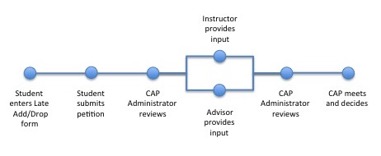
These are pages you will use.
- My Forms – create and locate your form for viewing and editing
- Undergraduate Late Add Drop Petition - create and manage your petition

The My Forms Page
Click start a new form to create new Late Add Drop petition.
Search for existing forms by Academic Term or by form type.

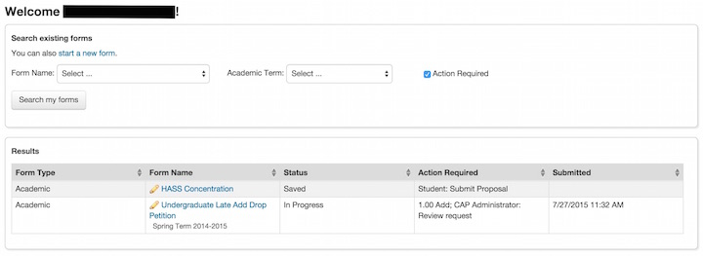
Results shows the type of form, the status, actions required, and the date and time submitted. The My Forms page defaults to show forms which are in a status of Saved or In Progress. You can find any saved or in progress petitions you want to manage here.

Start a new form
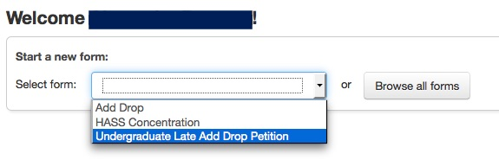
After you click start a new form, select the type of form from the drop down list.

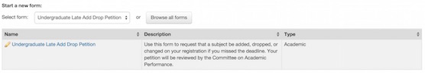
A description of the form appears. Click Undergraduate Late Add Drop Petition.
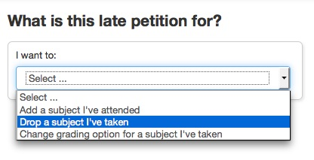

You are asked to select the type of petition you want. Select:
- Add a subject I’ve attended
- Drop a subject I’ve taken
- Change grading option for a subject I’ve taken.
Create Your Petition
Messages with pertinent information may appear when you start the form or when you take an action. Click OK, Cancel, or Continue to dismiss a message box. Click view to see the message again.

Add Subject
Select the academic term from the drop-down list, then enter the MIT subject number in the field provided. The MIT subject number will auto-complete as you type. Select the subject you want to add to your registration.
For cross-registered subjects use the enter non-MIT subject link.
A description of the form appears. Click Undergraduate Late Add Drop Petition.

Drop Subject
Select the academic term from the drop-down list, and your registration for that academic term will auto-populate. Click the box in the Drop column for the subject you are petitioning to drop and enter the date you Last Attended the subject. If you never attended the subject, click the box next to Never.
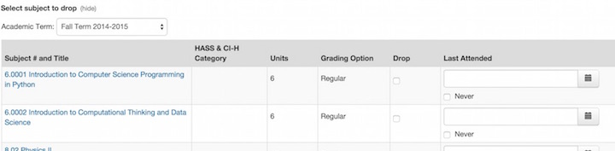
Change Subject Status
Select the Academic Term from the drop-down list, and your registration for that academic term will auto-populate. Then select your desired Grading Option for the subject you are petitioning to change.
The list will automatically shrink to list only the subject you selected. You may also see a warning about the consequences of your selection if the change will affect how your subject will count towards your degree or GIR requirements.
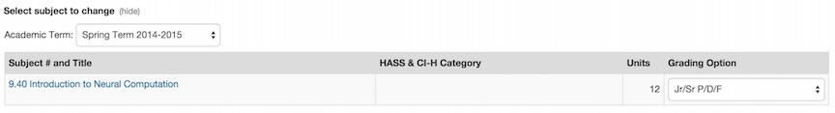
Student Statement
Once you have selected the changes you are petitioning to make to your registration, enter in the appropriate section a Student Statement explaining why you should be allowed to make these changes.
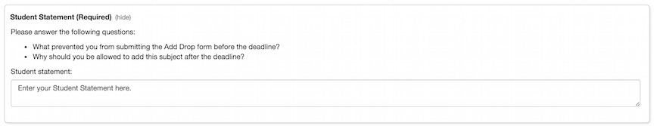

Save/Submit Your Petition
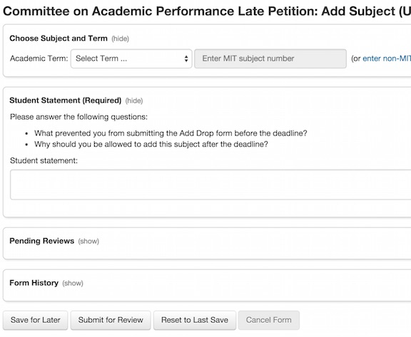
When you are done working on your petition for this session, you can either Save for Later to continue working on it at a later date or Submit for Review to send your petition to the CAP Administrator. Be sure a confirmation message like the ones shown below appears at the top of the petition after you click on the button.
You can find saved petitions on your My Forms page when you’re ready to continue editing and submit your petition.
Note: Once your petition is submitted for review, you will NOT be able to edit it anymore.

Manage Your Petition
Once your petition is submitted, you will receive email updates as it moves through the petition process and the reviewers complete their steps in the process. To check on the status of your petition as it moves through the process, go to the My Forms page.
Your forms and petitions are all listed here along with their status.
The Action Required column lets you know which step needs to be completed next.
You can also click on the Form Name of the petition to view the petition and more information on its progress.
.
The

Action Required Statuses
- Saved: You have saved your petition. It has NOT been submitted. You can continue to edit it.
- CAP Administrator: Review request: Your petition has been sent to the CAP Administrator for review.
- Student: Contact CAP Administrator: The CAP Administrator would like to consult with you before moving forward.
- Instructor: Review request: Your petition has been sent to the subject instructor for review and comment.
- Advisor: Review request: Your petition has been sent to your advisor for review and comment.
- Student: Contact advisor-name (A) & instructor-name (I): Your advisor and/or the subject instructor would like to consult with you before moving forward. This status may list one or both.
- CAP Administrator: Review instructor/advisor input: Your petition has been sent to the CAP Administrator to review the input to ensure the petition is complete and ready to be decided on at the next CAP meeting.
- Committee on Academic Performance: Review request: Your petition will be reviewed at the next CAP meeting.
- Refused – No action required: Your petition will not move forward to be reviewed by the CAP.
- Committee on Academic Performance: Tabled: The CAP needs more information before they can make a decision. You will be contacted and the CAP will review your petition again after obtaining it.
- Approved - No action required: The petition was approved and your registration will be updated automatically to reflect the change.
- Approved with Neglect – No action required: The petition was approved, but determined to be necessary only due to inattention or procrastination. Your registration will be updated automatically to reflect the change. There is an additional fine and future petitions of this nature are unlikely to be approved.
- Denied – No action required: The petition was denied and no changes will be made to your registration.

Pending Reviews
On the petition page, show details by clicking the show button. This will display a list of the pending actions and who is responsible for completing each of those actions on your petition.
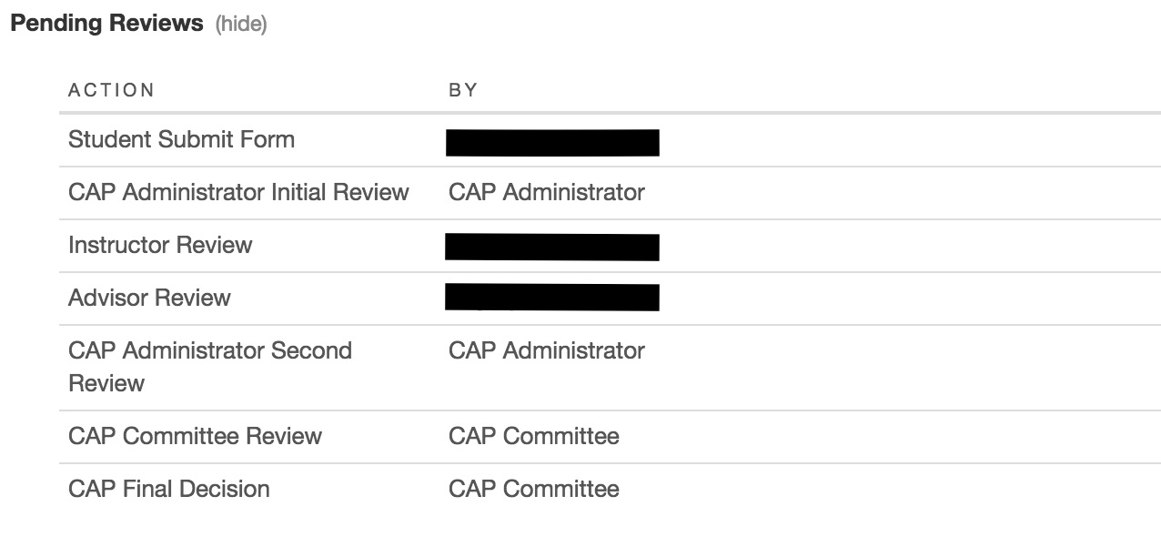
Form History
On the petition page, show details by clicking the show button. This will display a chronological list of all activity that has taken place on your petition.
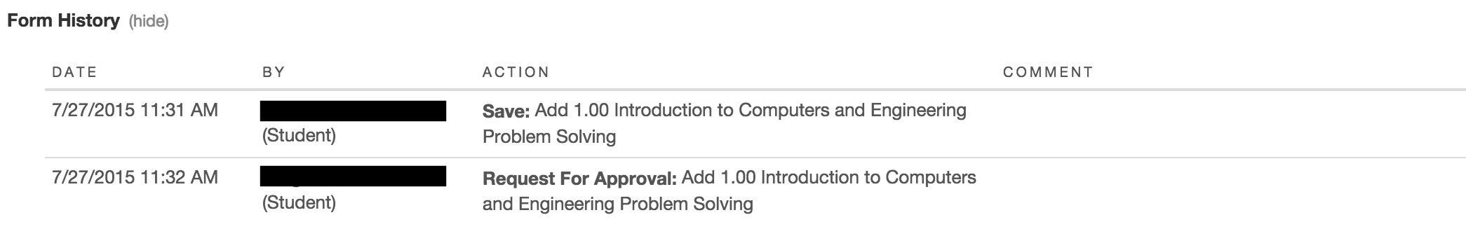

Cancel Your Petition
At any point before the final CAP decision, you can use the Cancel Form button to cancel your petition. Your petition will be deleted from the system and removed from the petition process entirely. You will lose any data you or reviewers have entered, and it will not be able to be recovered. If you still wish to petition, you will have to start all over at the beginning.
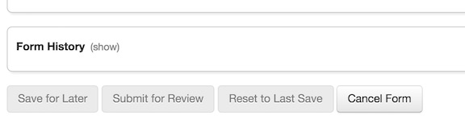
For more information:

  - Questions about adding or dropping subjects can be directed to your Academic Advisor or Department Academic Office.
  - Questions about the Undergraduate Late Add/Drop system can be directed to the Committee on Academic Performance at cap-help@mit.edu .

