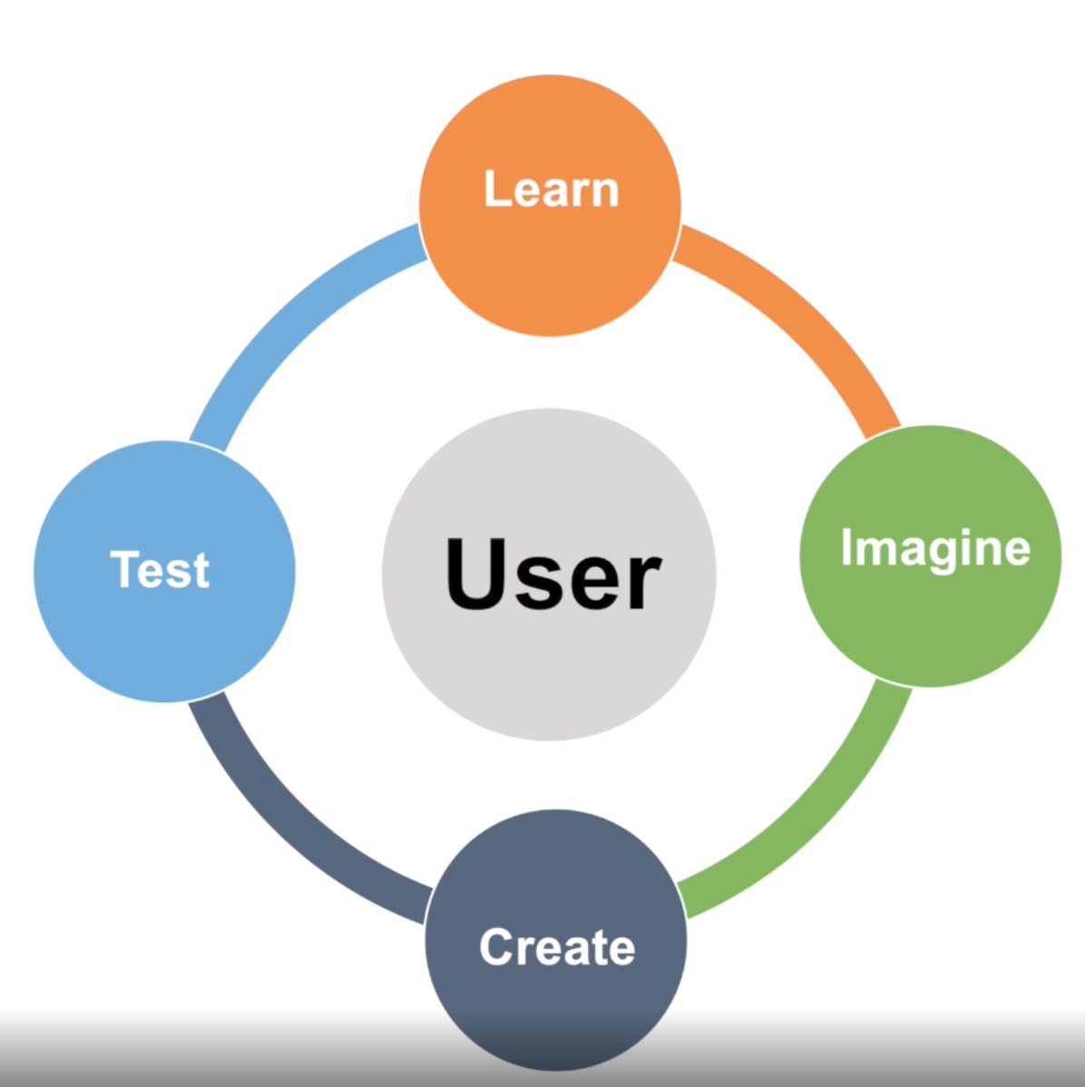
User-Centered Design (UCD) Process

