Project 5: Playground Safety

Background and Motivation. Public playgrounds provide many recreational, social and “play” opportunities for children. They are essential for healthy children, for healthy communities.

But since playgrounds are places where children are quite active, often involving themselves with playground equipment, accidents can and do occur. According to one source, “Over 200,000 children visit emergency rooms each year due to playground-related injuries. 15 child fatalities occur each year from playground equipment. 79% of ALL playground injuries involve falls. Falls also account for 90% of the most SEVERE playground injuries. 58% of all playground fatalities are due to strangulation.” https://www.brainline.org/article/playground-safety

So, we must be very concerned about playground safety. That is the focus of this Project-Based Learning unit. Playgrounds are situated in different types of locations, on playground-dedicated spaces, on school grounds, in neighborhood public parks, etc. A typical American community may have ten or more public playgrounds.

Student Activities. Students will start their project by reading related web-based materials on playground safety, and they will become familiar with the playground 24-entry safety checklist included here as part of this project description. (Also found here: https://www.dhhs.nh.gov/oos/cclu/documents/playgroundchecklist.pdf) They should discuss among themselves how they want to assess the safety of their own community’s playgrounds, guided by but not directed or limited by the safety checklist. Next it is recommended that the Team visit one or more playgrounds during high-use hours, first just noticing issues that may or may not be safety issues, and then looking at the checklist to see how applicable those items are to the playground(s) visited. We suggest that the students use the provided checklist, but rather than simply checking or not checking each item, they give a score between 0 and 5 to each item. Here, a “5” is perfect, no problem. A “0” is horrible, perhaps indicating the need to shut down that offending facility. After visiting the playground(s), the students may decide to remove one or more items from the checklist as not relevant to their community, and they may want to add additional ones; this is all fine. The checklist is only to get students started!

When the student Team is ready, with their probably modified checklists, they should then go out during playground high-use hours to officially grade each and every playground in the community, but no more than 15. If there are many playgrounds, then the Team will need to split up, with perhaps two from each team assigned to a playground. Eventually the students will return with all checklists filled out, not with checks, by with each entry being a number from 0 to 5. They should discuss their results among the team to see if they have discovered any serious safety issues. Then we want them to create two types of histograms:

- The first histogram would depict total safety scores over the collection of playgrounds visited. For any given playground, its total safety score is the sum of scores from its completed checklist. This histogram will have few numerical entries, only one total safety score for each playground. With 15 playgrounds, for instance, there would be 15 data entries to create this first histogram.
- The second histogram should build from each and every 0-to-5 score for each of the entries in all of the checklists. The histogram’s horizontal axis would display the integers 0, 1, 2, 3, 4 and 5, representing the six different possible grades on any playground safety issue. We doubt that the student-finalized checklists will have as many as 24 entries. Suppose that the checklists have 16 entries and the students survey 10 playgrounds; then this aggregate 2nd histogram would be built from 10*16 = 160 data entries.

For each histogram, the students should the display the mean, median, mode and 5% tail boundaries. Then they should discuss results, especially the utility of the mean or average only as providing useful information about playground safety. They should also discuss the insights they obtain from each of the two types of histograms.

If possible, the students (perhaps with the assistance of their teacher) should arrange a visit with the professionals in the community charged with playground safety. At the meeting, they present their results, have a broader discussion, and seek feedback from the professionals.

Finally, the students write up their report and present their results at the Final Event.

Potentially useful web sites:

Playground Safety (CDC)
https://www.cdc.gov/safechild/playground/index.html

Staying Safe on Playgrounds
https://bit.ly/3hkHy0B

Global playground safety standards
https://bit.ly/35vrRBG
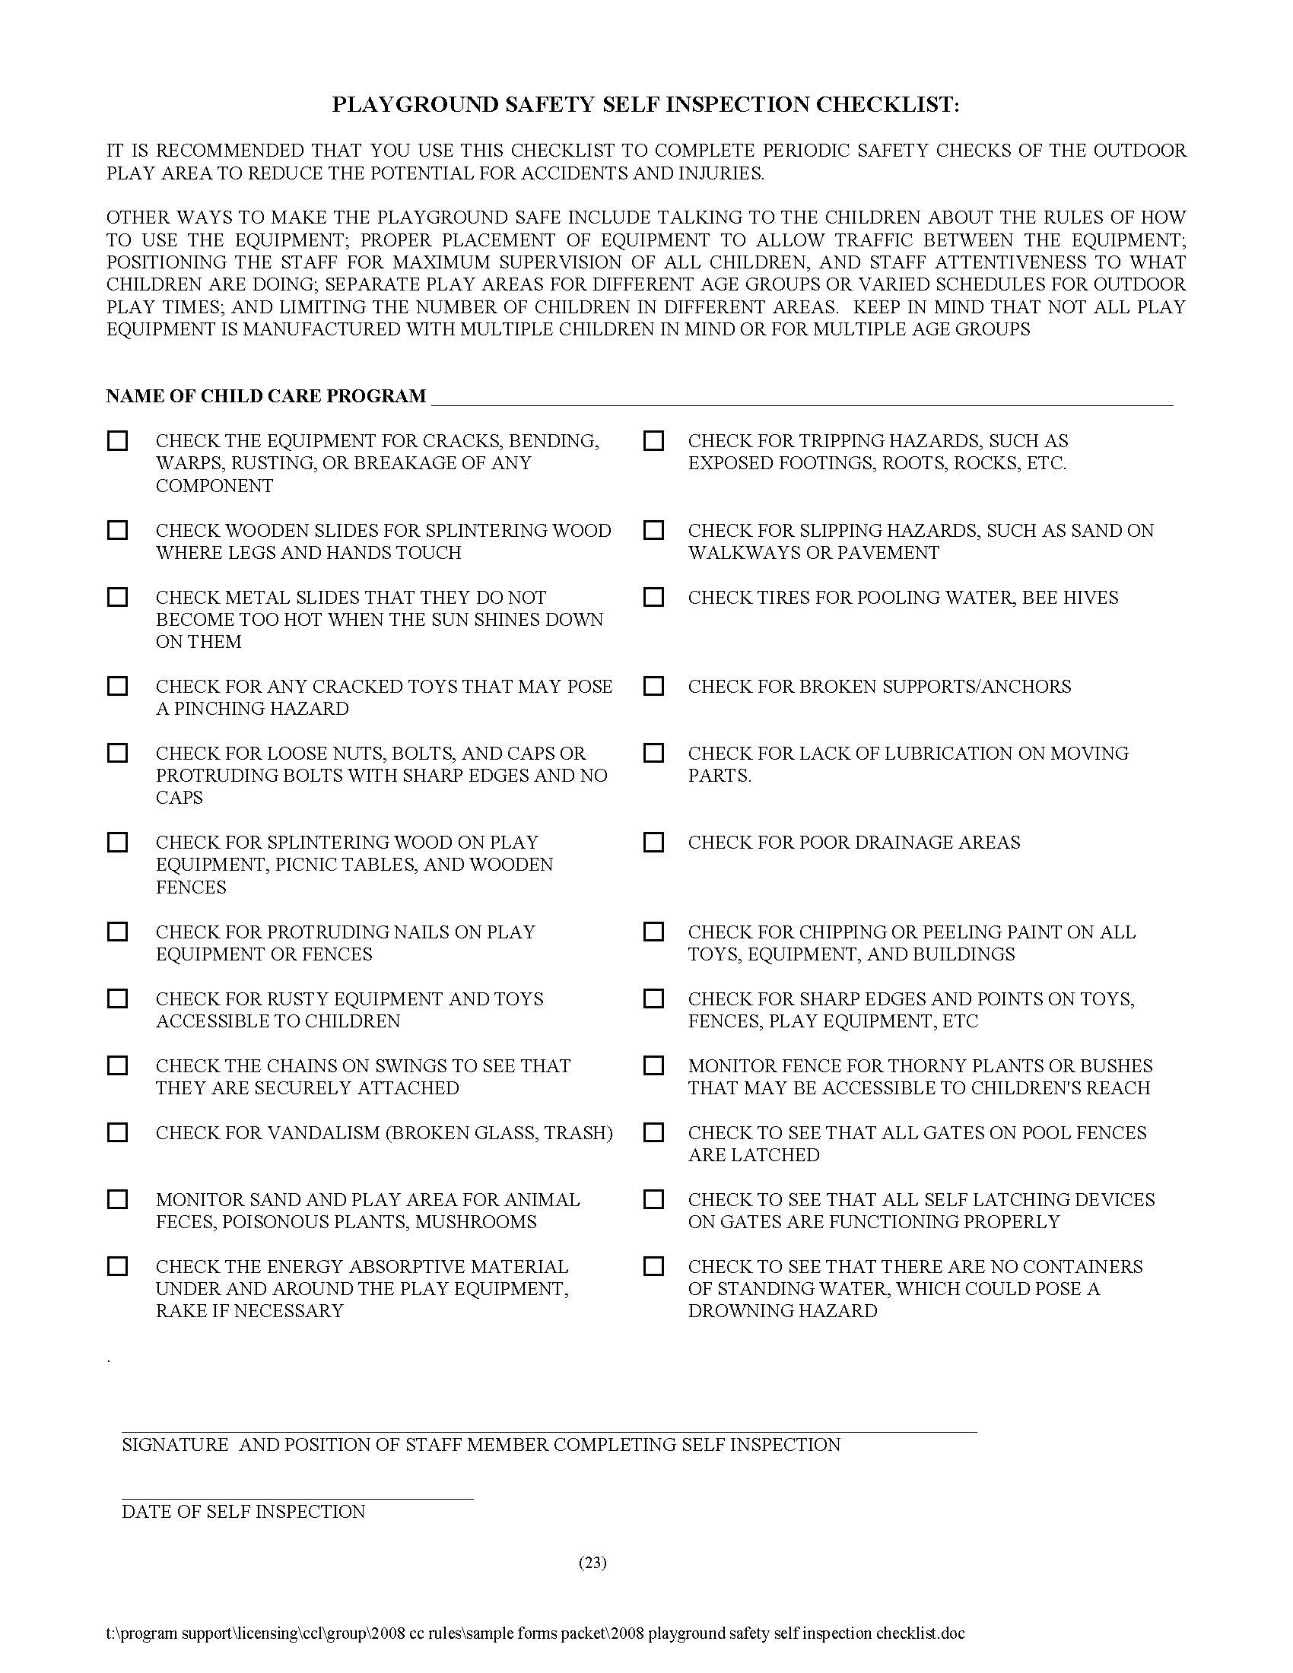https://www.dhhs.nh.gov/oos/cclu/documents/playgroundchecklist.pdf

