Flowchart Resource Handout

What is a Flowchart?

A flowchart is a visual representation of the sequence of steps and decisions needed to perform a process. Each step in the sequence is noted within a diagram shape. Steps are linked by connecting lines and directional arrows. This allows anyone to view the flowchart and logically follow the process from beginning to end.

Flowchart Symbols
Flowcharts use special shapes to represent different types of actions or steps in a process. Lines and arrows show the sequence of the steps, and the relationships among them. These shapes are known as flowchart symbols.

Common Flowchart Symbols:
- Rectangle Shape - Represents a process
- Oval or Pill Shape - Represents the start or end
- Diamond Shape - Represents a decision
- Parallelogram - Represents input/output

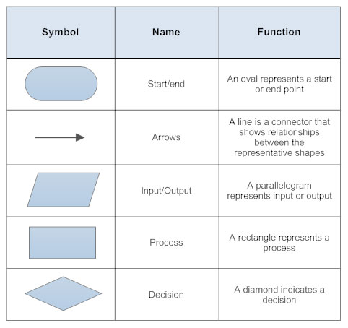

How to make a flowchart in a few simple steps:
- Determine the purpose or function of the flowchart
- Add steps and connect them with arrows
- Add decisions or split paths
- Show any loops back to previous steps
- Share your flowchart

(The above is borrowed from SmartDraw)

Flowchart Software Options

Below are three highly recommended Flow Chart software providers.
There are many others available online.

1. Creately [https://creately.com] provides an excellent Flowchart Tutorial https://creately.com/blog/diagrams/flowchart-guide-flowchart-tutorial/
and the company’s basic flowchart plan is free.

2. Lucidchart (https://www.lucidchart.com/users/registerLevel?referer=https%3A%2F%2Fwww.lucidchart.com%2Fpages%2F) offers a free service for individual users that includes an introductory shapes library and 100 basic templates.

3. Smartdraw (https://www.smartdraw.com/?r=dpm-fcs) It also allows users to sign up to use its software to try for free.

