Student Team Challenge #1
a | b
Figure 1: A simple example of stock-flow concepts: (a) flows, (b) stocks
Given this information, can you use Figure 1a to estimate the number of current infected from new infection and daily recovery? Hint: From January 1st until 10th, every day we are adding 100 new cases, and after January 10th, we are still adding 100 new cases each day while 50 are recovering each day (net increase of 50). Figure 1b, the dotted line shows the trend of current infected. As you see, the number of infected people is still increasing. And that continues as long as inflow > outflow (which was the case in this simple example). The bathtub analogy helps here too: water is flowing in to the bathtub much more than draining out, thus water is accumulating in the bathtub. This is physics ruling!

Student Team Challenge #2
The previous problem was a simple case. Consider the following. Figure 2a shows number of new infections, and daily recoveries. Daily infected (black line) starts with 50 for 5 days, then becomes 100 per day for 10 days, then back to 50 and finally to zero. Recovery (green line) follows the same pattern with a 10-day delay. Can you estimate “cumulative infected”, “cumulative recovered” and “current infected?”
a | b
Figure 2: A more realistic example of stock-flow concepts in infectious diseases

Student Team Challenge #3
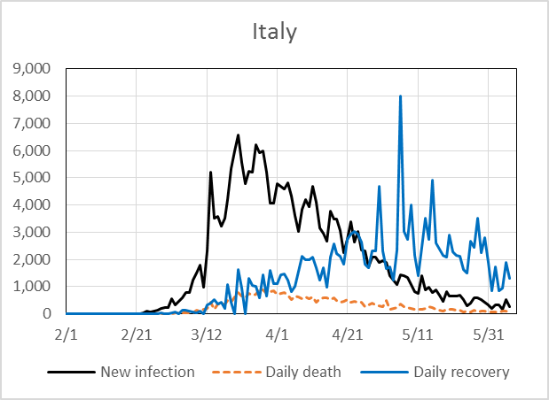  a: flows: daily new infection (inflow), daily death and daily recovery (outflows) | 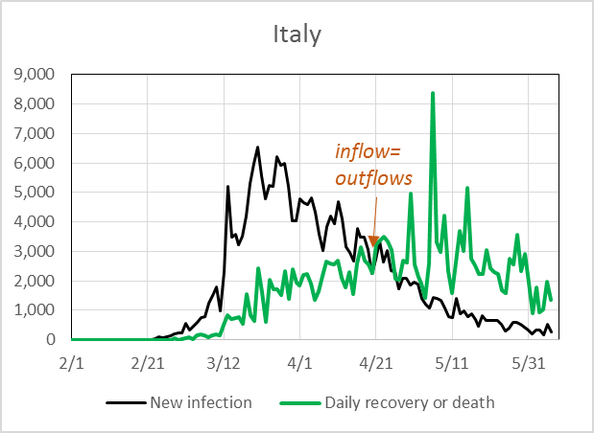  b: same as a, with one graph for total of daily death and recovery (outflow) pointing to the first date at which inflow=outflow

This is the daily trend of infections from the 2020 coronavirus in Italy. At the time of designing this challnege, the disease was still spreading.
The questions are: What is the cumulative number of Infected and what is the cumulative number of Recovered. We unfortunately had death too. What is the cumulative number of deaths? Plot these variables over time. When did we pass the peak of infection (the maximum point in current infected)? You can use the graph and draw current infected. Note that since there is death too, outflow is daily recovery plus daily death. Can you tell that without even drawing the current infected graph? Yes! Hint: maximum of the stock should be on one of the points that inflow=outflow!

