Potential project ideas following background lessons that looked at the heat capacity of water.

Earth’s Climate and the Current Heat Capacity of the Ocean.

A good starting place might be the following article from NOAA’s Climate.gov website.

LuAnn Dahlman and Rebecca Lindsey. “Climate Change: Ocean Heat Content.” NOAA Climate .gov. August 1, 2018. https://www.climate.gov/news-features/understanding-climate/climate-change-ocean-heat-content

From this article:
With increases in global warming the heat stored in the upper regions of the ocean and has greatly increased significantly over the past 25 years. As this continues the stored heat will eventually be released compromising the ocean’s ability to stabilize the Earth’s climate and further increase global warming.

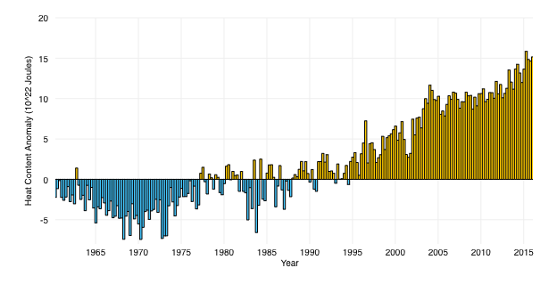

This graph (source data) shows differences from the long-term average global ocean heat content (1955-2006) in the top 700 meters of the ocean.

Students may have projects that include the following:

• How is such data currently collected? What are challenges as to how this data is collected?

• How is data such as that in the above graph made more meaningful?
For example: What does “10²² Joules” mean in terms of energy use?

• Develop predictions that look at other aspects of climate or ocean conditions. Examples may include:
Changes to the water cycle; frequency of storms; ocean salinity; or sea level rise. Support the predictions with data
Engineering Challenge: Design and possibly construct a prototype for an efficient heating or cooling system that takes advantage of the heat capacity of water.

Students may first wish to research radiant heating, solar, or geothermal systems for background and inspiration.

Things to consider:

•Materials and devices needed
•Energy source(s).. renewable? non-renewable?
•How to determine efficiency
•Costs

