Special Properties of Water

Lesson 4: Water expands when it freezes. Ice floats.

Water is a unique material. Not only can it be found as a solid, liquid, and gas at normal temperatures, its solid state is less dense than its liquid form. In other words, ice floats.
Imagine a world in which ice was more dense than liquid water. Imagine if ice sank.
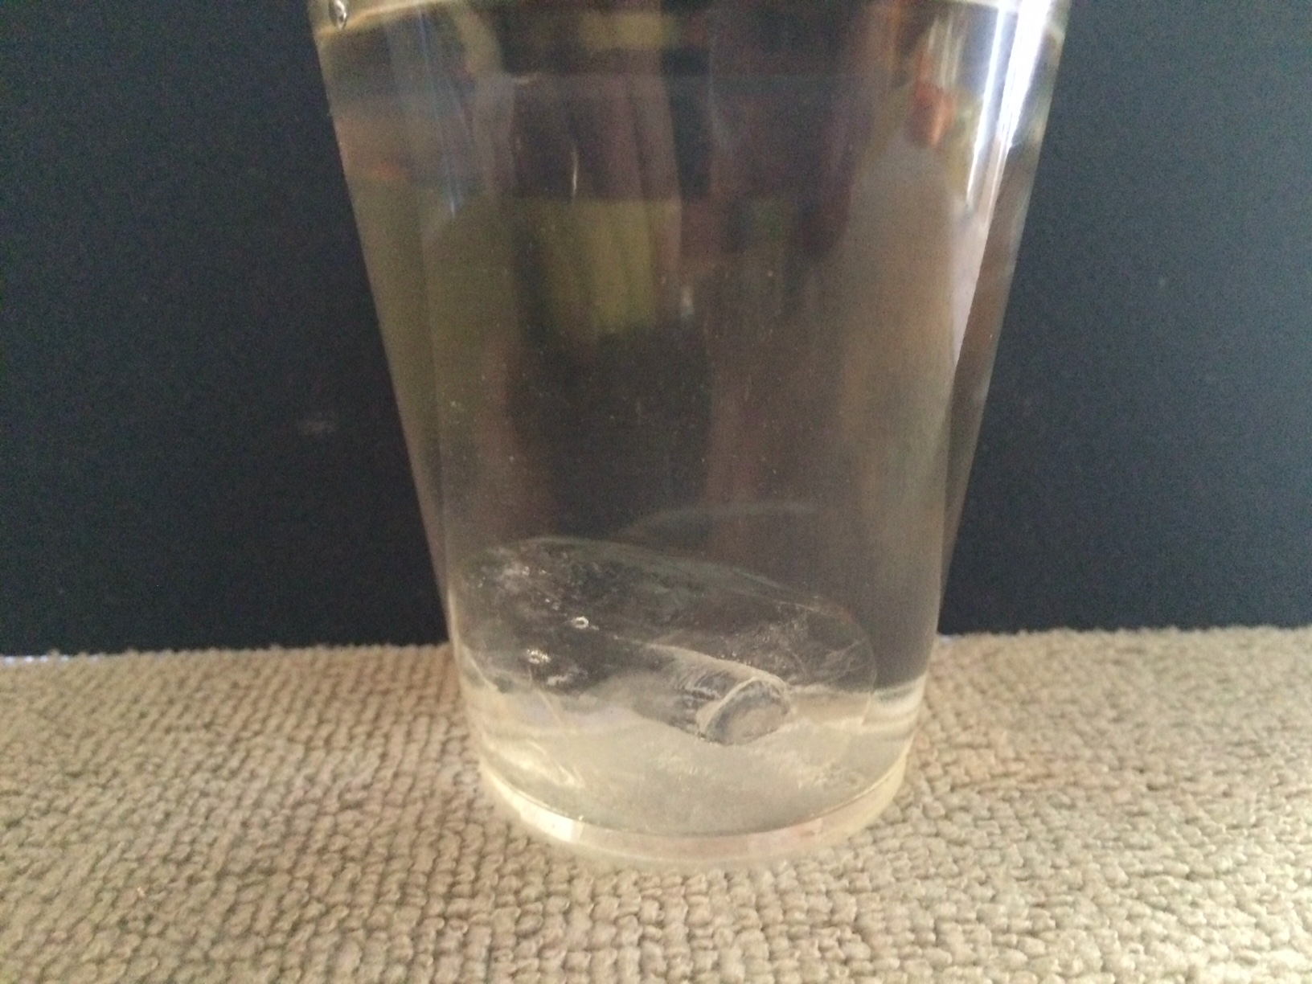
Ice sinks in alcohol
To visualize this, drop a chunk of ice in a glass
of alcohol; it sinks.

If ice were to sink in liquid water, lakes and ponds in colder climates as well as Earth’s polar seas would freeze solid during colder months and might never completely melt. Freshwater ecosystems in colder regions would be very different. There would be no sea ice or ice bergs; the Titanic would never have sank.
When water freezes its volume increases without adding mass. This spreads out its molecules making ice less dense than liquid water. The expansion of water when it freezes is a powerful force. Ice forming in the cracks of bed rock can break off large pieces of rock creating landslides. Expansion happens as ground freezes resulting in damage to roads and buildings. Pipes and water cooled engines will crack and break if exposed to low temperatures and the water in them freezes.

The force of water’s expansion as it freezes can be demonstrated by filling a glass jar to the rim with water and closing the lid tightly. Place the jar in a bucket and then put the set up in a freezer overnight. The bucket holds
any loose pieces of broken glass.

Demonstration: Observing the force of the expansion of water when it freezes in a glass jar.

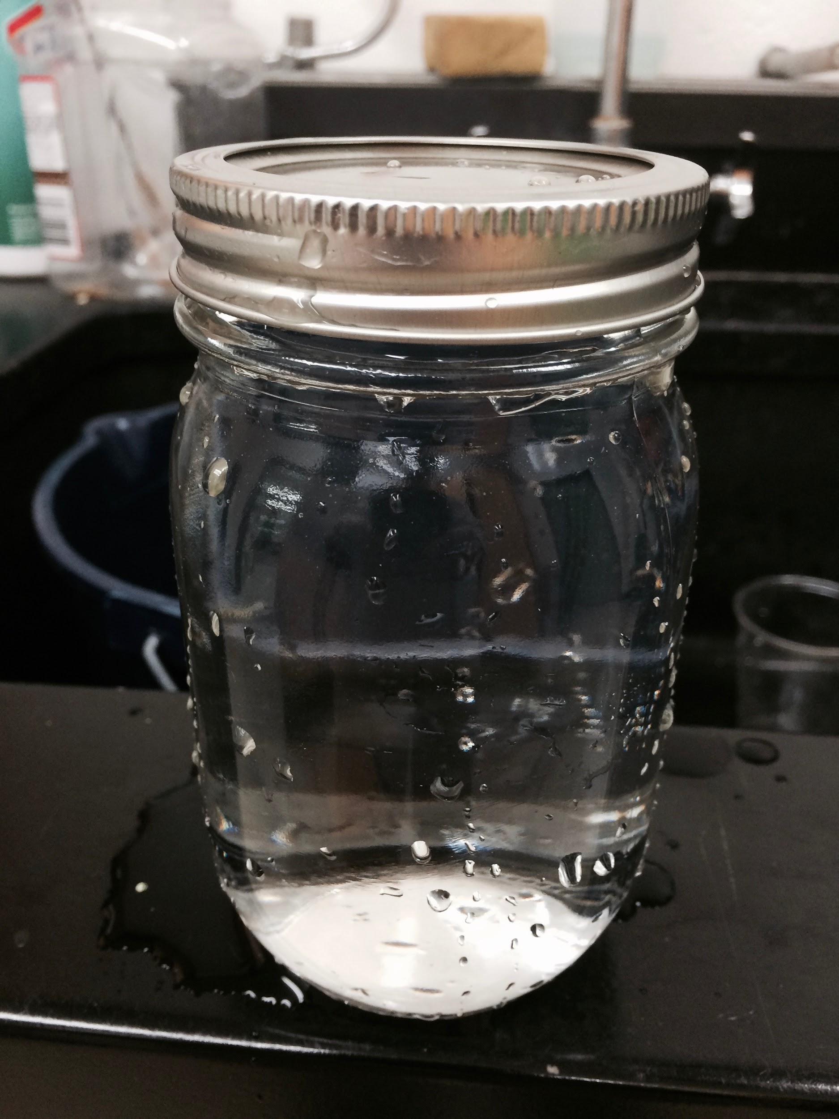
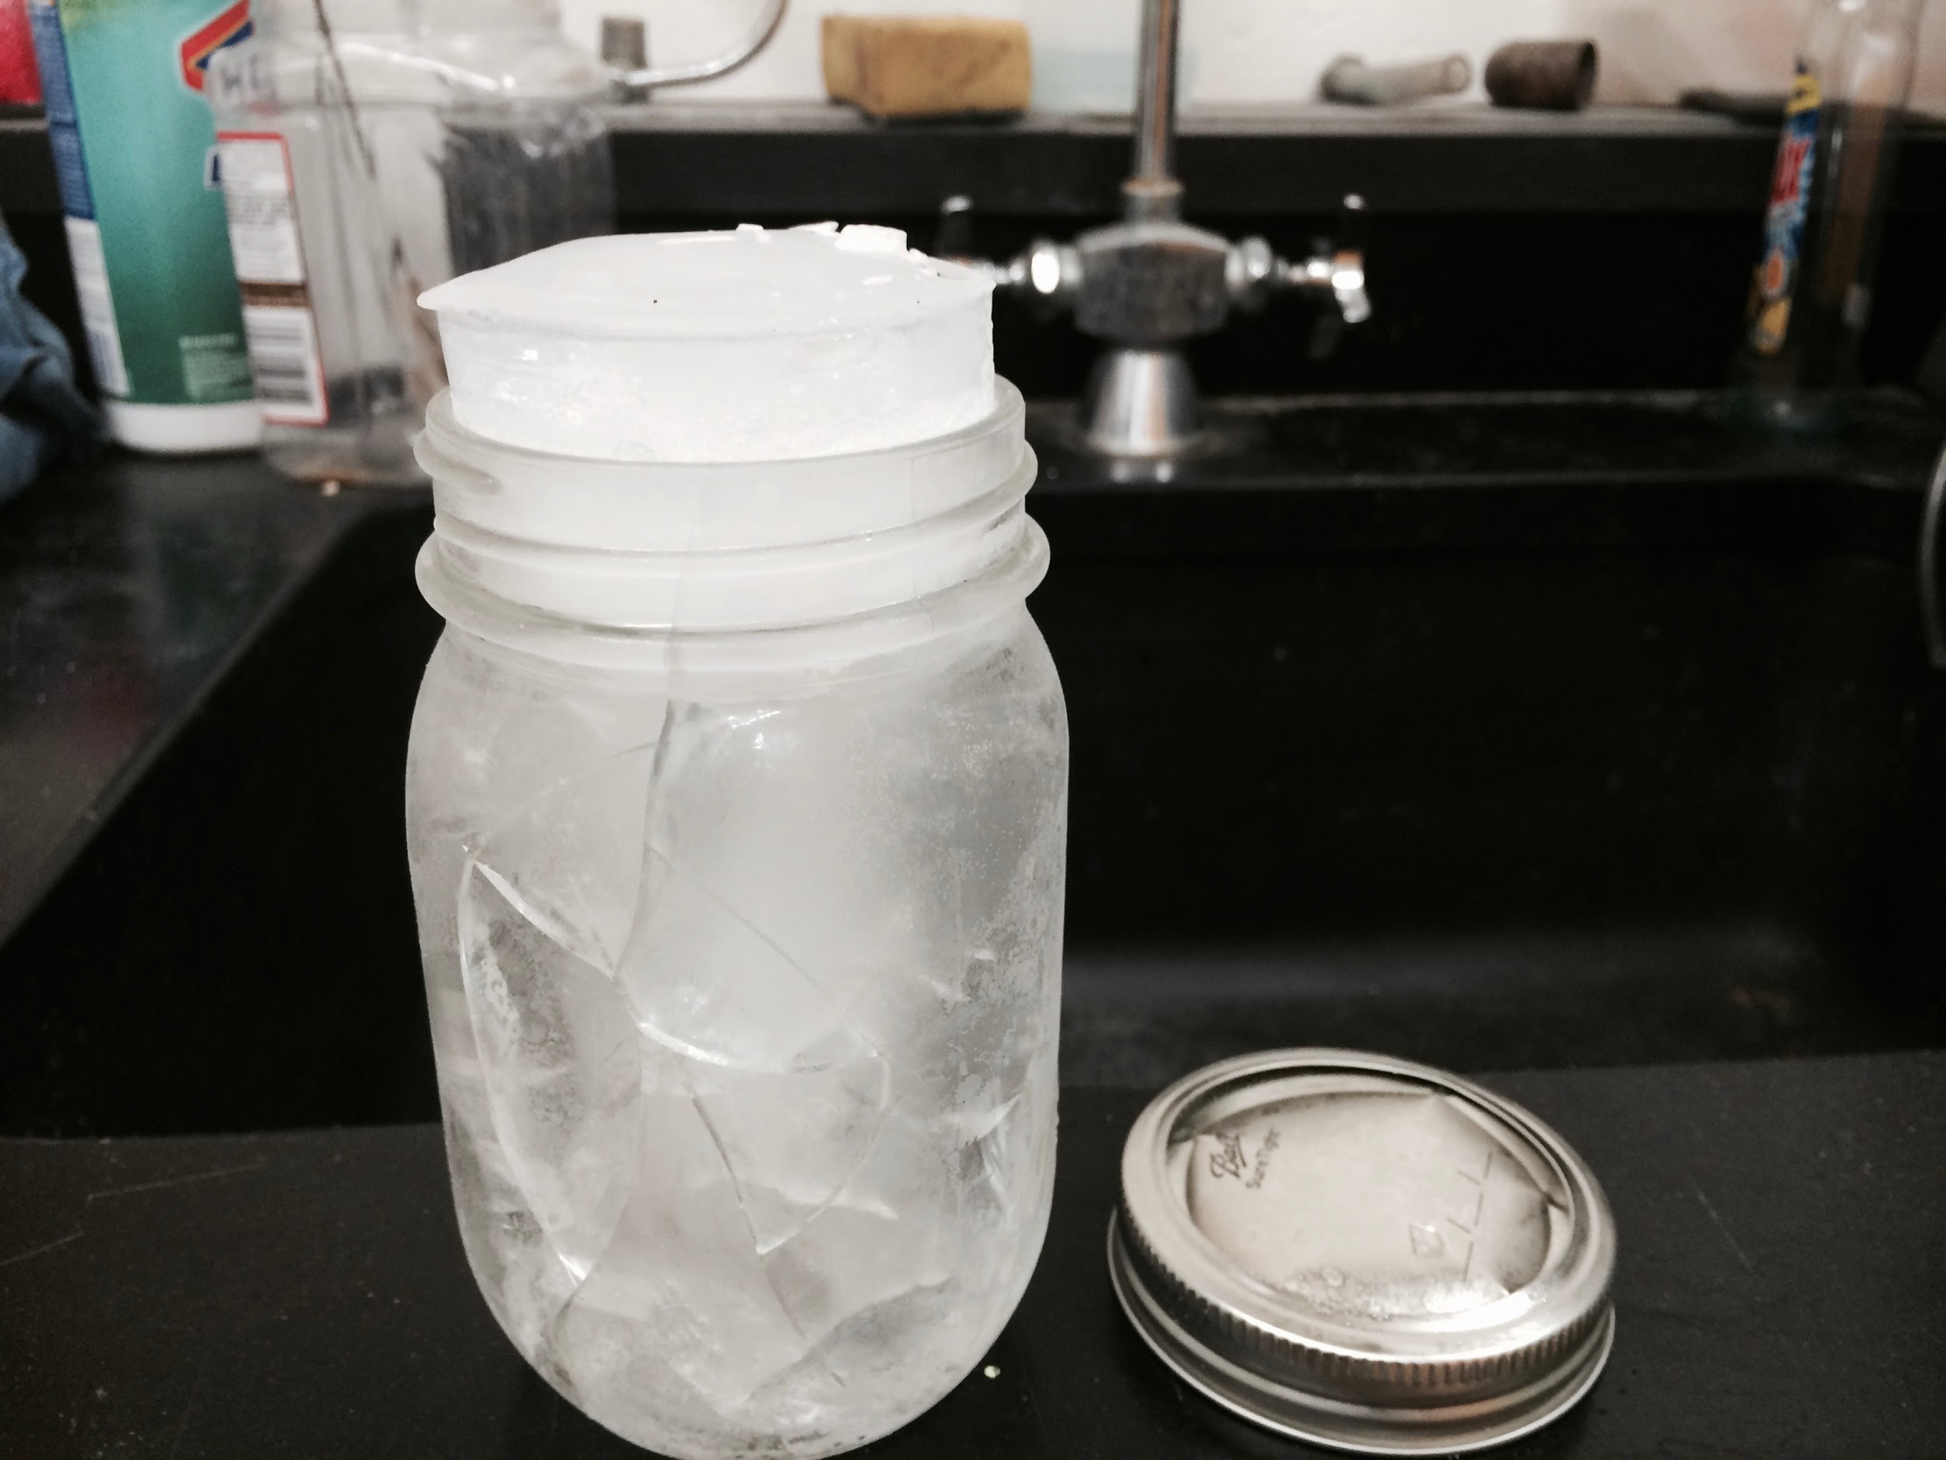
Jar filled with water with lid screwed on tightly.
Water in jar freezes and expands forcing the lid off the top of the jar and cracking the glass.

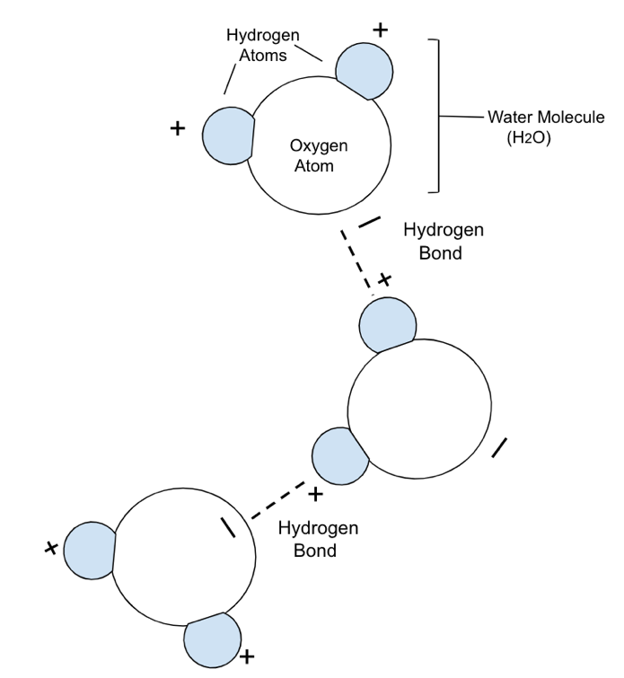
No other substance expands when it goes from a liquid to solid state, so why does water ?

Once again it is due to the shape of the water molecule.

Each water molecule is attracted to others with their Hydrogen (+) side pulling on the Oxygen(-) end of a neighboring molecule. This force forms a bond between the molecules known as a “Hydrogen bond” which becomes stronger as molecules lose their kinetic energy (heat) and form ice.

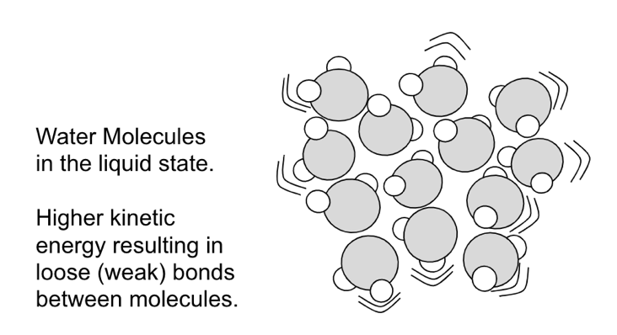

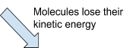
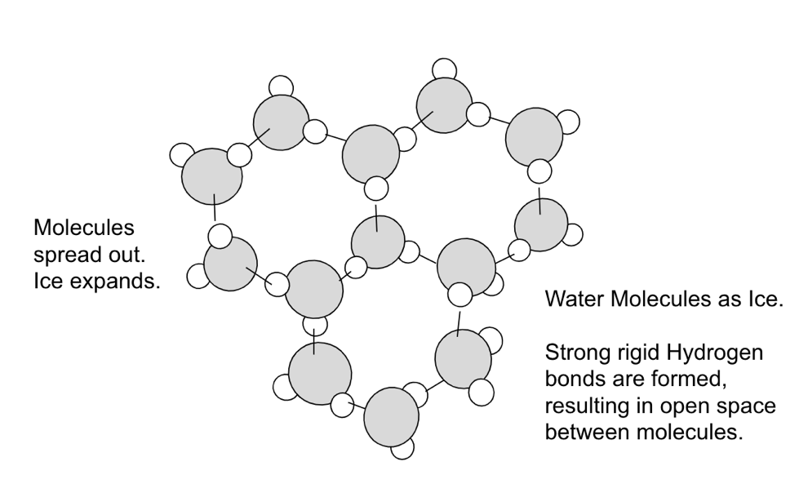

To help gain a better understanding of phase changes at the molecular level, explore the following simulation : States of Matter: Basics. PHET Interactive Simulations from the University of Colorado at Boulder.

https://phet.colorado.edu/sims/html/states-of-matter-basics/latest/states-of-matter-basics_en.html

In this simulation you can control the conditions (heat and pressure) which alter the kinetic energy of molecules to see how they change between solid, liquid, and gas phases of matter.
Images from :States of Matter: Basics. PHET Interactive Simulations from the University of Colorado at Boulder.
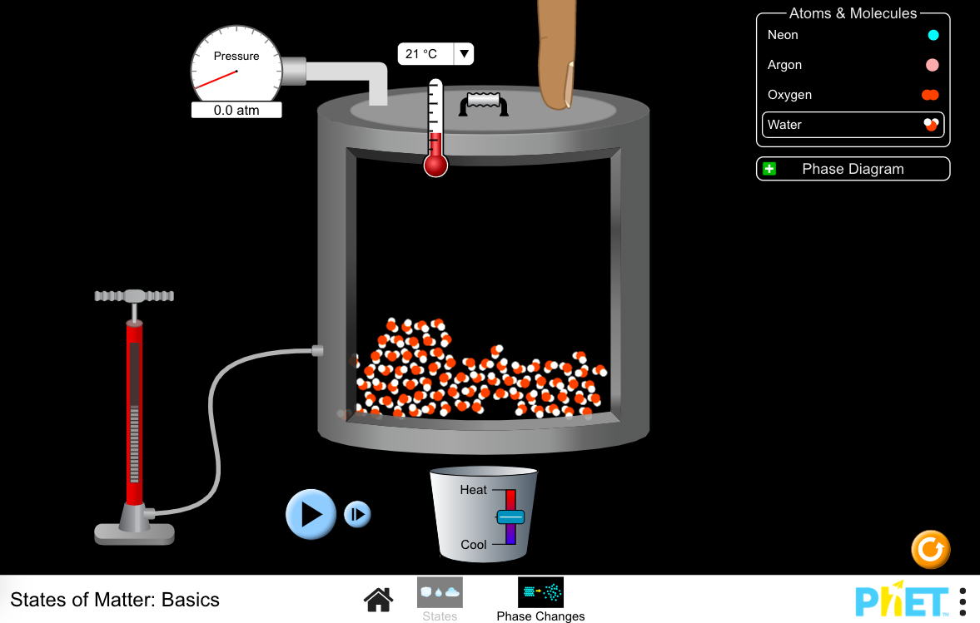
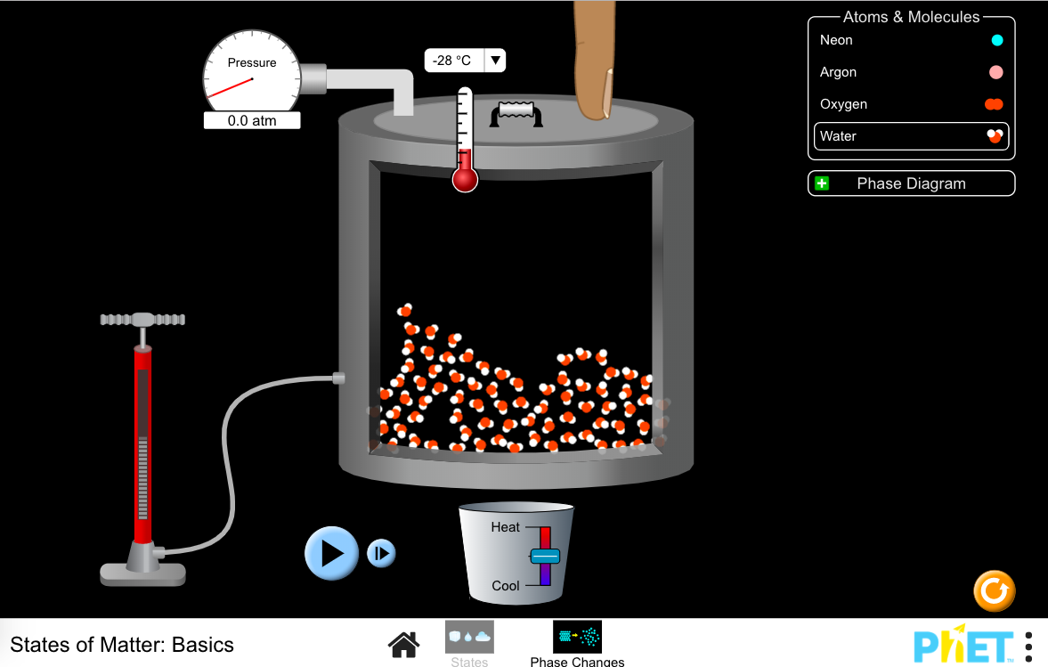
Water molecules in liquid state. Water molecules in the solid state.

