Activity guide for in-class teacher:

Before the lesson starts, it would be better to divide the class into pairs. Pair up students that are not seated next to each other. Most activities are group activities, so throughout the lesson, students will remain in the same pairs and groups.

Activity 1: Pick the solution that you think is the best of three
This activity will happen in pairs.

Activity 2: Critiquing 5 different solutions
- This activity will happen in pairs.

- Things to remind the students:
- You are the user
- You live on less than $2 per day
- You have limited, unreliable access to electricity, clean water, sanitation, quality education and healthcare.
- Brainstorm and fill this table: try to come up with more critiques than pros.

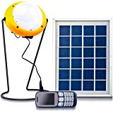
If students are curious to learn about the success of each technology that they evaluated, here is some information for you to share with them AT THE END OF THE LESSON.
1. Solar lanterns (multiple brands): One of the most successful products in the developing world that has been adopted by millions of people living in poverty.

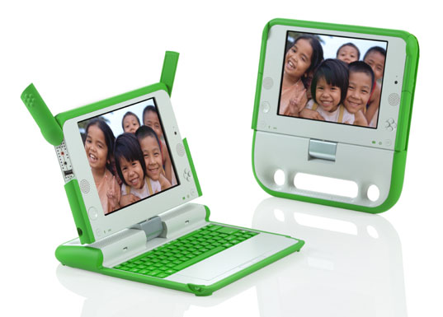
2. One laptop per child: It is considered as one of the biggest failures. People living in poverty cannot afford to buy laptops. Even if the laptops are subsidized or given for free, they don’t have the resources to maintain one. Electricity is unreliable and if something breaks down, access to repair is always a problem in poor communities. These laptops also had several technical problems.

3. Zeer Pot: Many communities in the developing world use clay pots to store water- it keeps the water cool. With little modification, these pots can be used as mini refrigerators to store vegetables. There are many versions of this method. It is being used in many communities as it is low cost, effective and made from easily available materials.

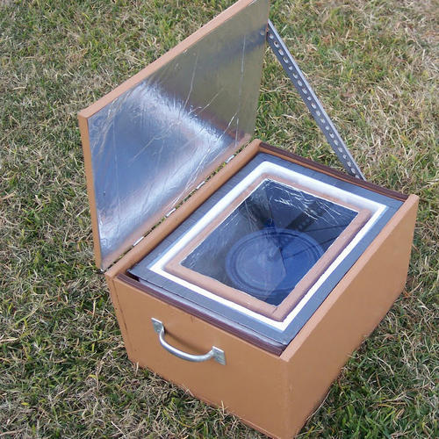
4. Solar box cooker: This technology has never proven to be feasible. I don’t know of any communities where this is being used regularly. Innovators still keep investing time and money into it, which in my opinion is a waste.

5. Treadle pump: A successful solution being used by millions of smallholder farmers in Asia and Africa.
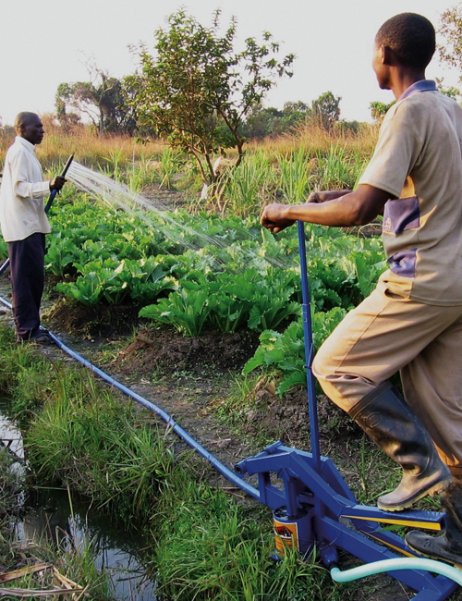

Activity 3: Learn- interviewing the user
- 2 pairs will be merged together to make a team of 4.
- of the 4 members, 2 will be “interviewers or designers” and 2 will be “interviewees or users”
- They will remain in the same pairs and groups for the entire lesson.

How to interview: Things to remind the students

- The focus here is (thematic area _________) in your school. Hence the interview will focus on understanding the challenges users are facing and specific needs they have for a solution with respect to that.
- Ask why- Even when you think you know the answer – try to understand why this is really a challenge.
- Pay attention to nonverbal cues - Be aware of body language and emotions.
- Ask open-ended questions that do not suggest answers. For example, “What do you think about the library?” is better than “Don’t you think the library is great?”
- Make sure to write down exactly what the person says, not what you think they might mean. Ask clarifying questions if you don’t understand what they’re saying.
- In a team of three students- 1 asks the questions, 2 writes down the answers, 3 observes and makes observation notes.

Sample interview guide: Start with general questions and then dig deeper. Add your own follow up questions where needed.

- What is your overall impression of the (thematic area)?
- What are some things you like about this (thematic area)?
- Why do you like those things? Dig deeper into each one.
- What are some things you don’t like or wish to be changed/improved about this (thematic area)?
- Why? Dig deeper into each one.
- How do those things affect you?
- How would you like to see those things changed or improved? Why?

Activity 4: Imagine
- This activity will happen in a group of 4, all members will act as designers and imagine the solutions together.

4 a. Select a problem: From the list of problems the designers uncovered from the users, they have to select one to work on. Select a challenge that is: important to the user, practical to solve with the time and resources you have, and the whole team is excited to take on. Once you have selected your challenge, use this guide to create a problem statement. 2 min.

And then you have to define the problem: Follow this guide to define your problem.

(User/ group name)

needs a way to _________________________________________________________________
(User need)

because ______________________________________________________________________
(insight as to why)

But, ___________________________________________________________________.
(current situation and challenge standing in the way)

4b. Brainstorm: Things to remind the students
- Go for quantity- The goal is to generate as many ideas as possible.
- No judgments- encourage wild ideas
- Be visual- each person should use post-its to write their ideas during brainstorming and put them on the board.
- Stay focused on the problem
- Don’t be too attached to your own ideas

Step 1: Individually generate at least 5 (more if possible) ideas. Write them down, one per post-it. 2 mins.

Step 2: Get into your group and share the ideas. Make sure each team shares their ideas and others listen. Once everyone’s ideas are shared with the team, generate ideas together by either combining, improving or coming out with a new idea.

Activity 5: Create
- This activity will happen in a group of 4, all members will act as designers and create the solutions together.

- Items to provide to each team: cardboard boxes, tapes, scissors, etc if possible.

- Things to remind the students while prototyping:
- Start making. Even if you aren’t sure what you’re doing, the act of picking up some materials will be enough to get you going.
- Don’t spend too long on one prototype. Let go before you find yourself getting too emotionally attached to any one prototype.
- Build with the user in mind. What do you hope to test with the user? What sorts of behavior do you expect? Answering these questions will help focus your prototyping and help you receive meaningful feedback in the testing phase.

Activity 6: Test
- This activity will happen in groups of 4.
- But students will go back to their roles as designers and users as they did in activity 3. 2 will be “interviewers or designers” and 2 will be “interviewees or users”

Things to remind the designers:
- Show don’t tell: Put your prototype in the user’s hands – or your user within an experience. And don’t explain everything (yet). Let your user interpret the prototype. Watch how they use (and misuse!) what you have given them, and how they handle and interact with it; then listen to what they say about it, and the questions they have.
- Create Experiences: Create your prototypes and test them in a way that feels like an experience that your user is reacting to, rather than an explanation that your user is evaluating.
- Ask users to compare: If you made multiple prototypes, testing them gives users a basis for comparison, and comparisons often reveal hidden needs which will be very useful for you, the designer to know.

Things to remind the users:

- You are the user
- This solution was made FOR you
- You have the full right to critique this solution
- Your honest and specific feedback will make this solution better
- Try the prototype and think: Does it solve your problem? How and how not? What do you like about it? What do you not like about it? What changes would you make to make it more usable and enjoyable?

