Examples of POSITIVE versus NEGATIVE correlation

A positive correlation means the variables increase or decrease at the same time:

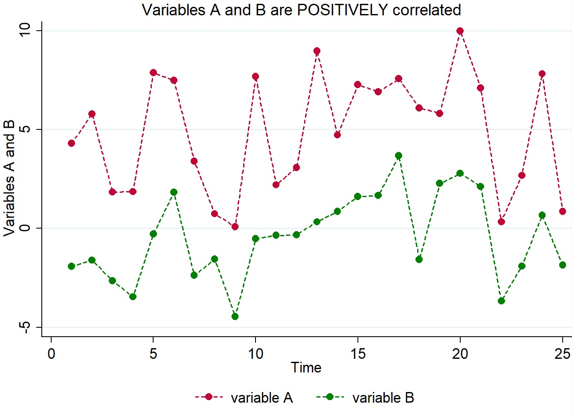

A negative correlation means that one variable increases as the other decreases:

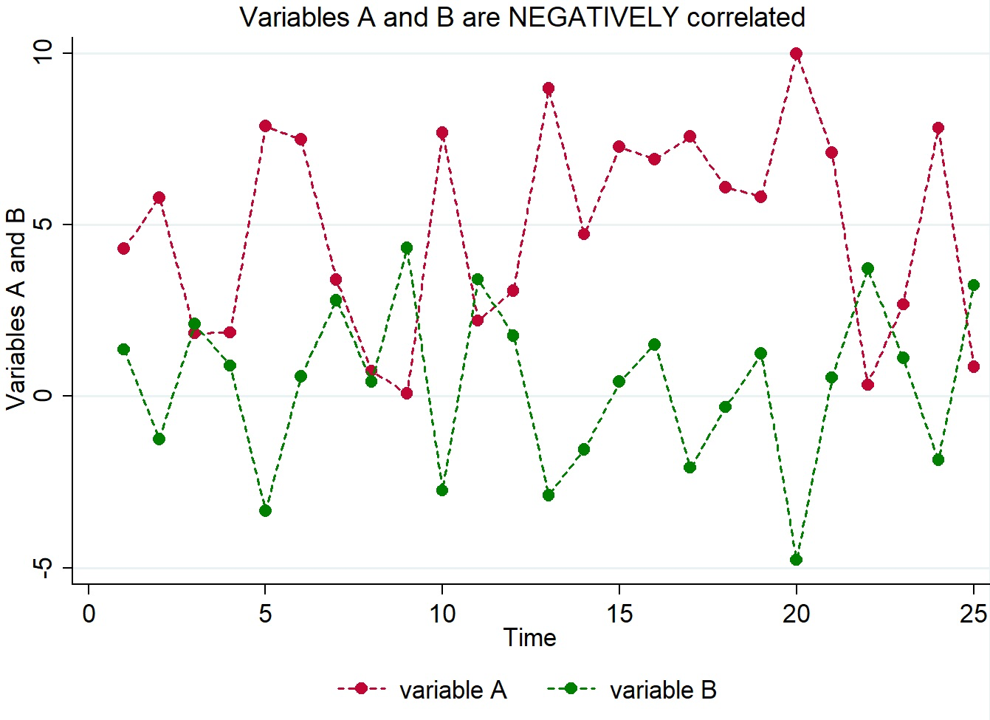

Examples of STRONG versus WEAK correlation

A correlation is called “strong” when the variables move together almost in unison:

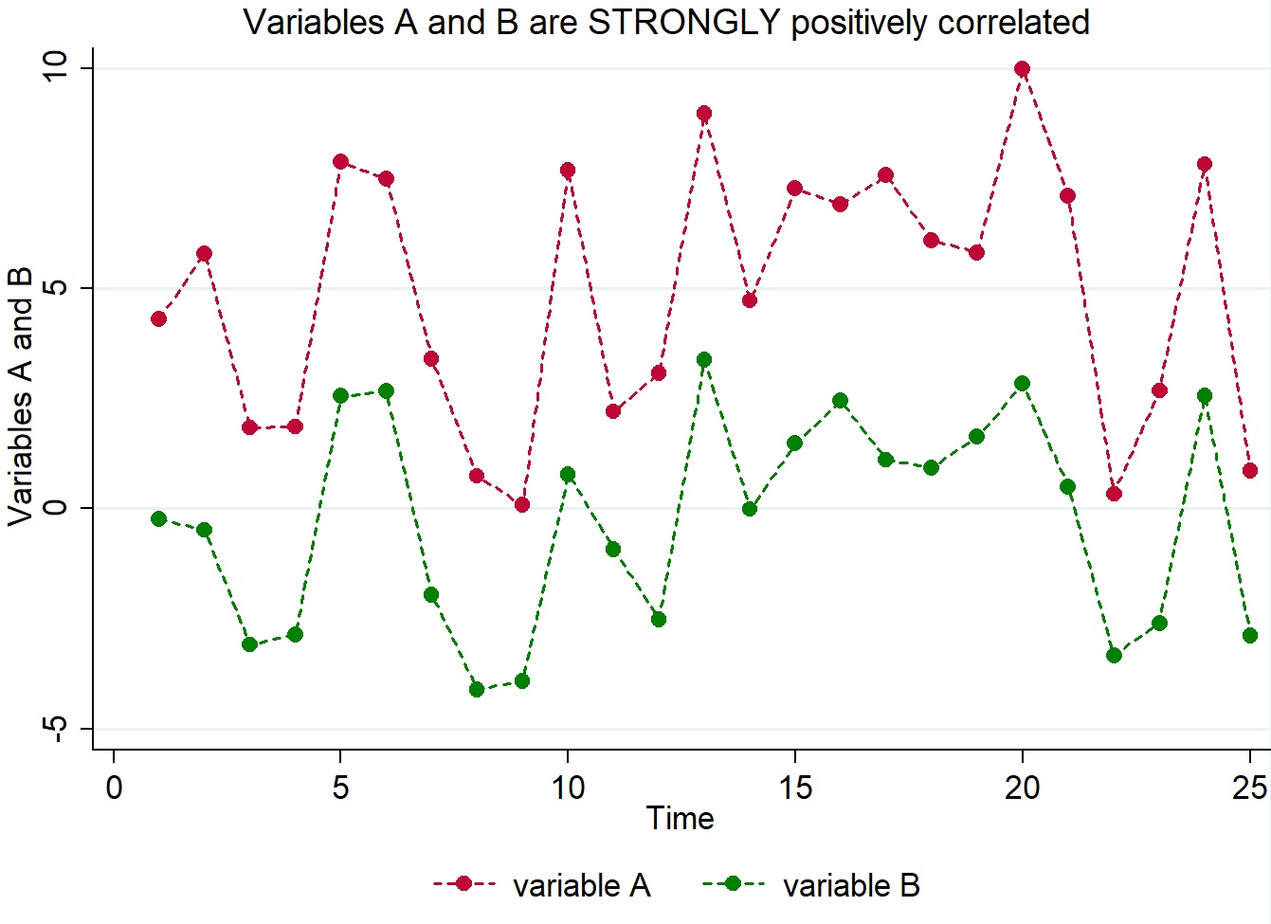

A correlation is called “weak” when the variables just barely move together:

