***Homework for Fence Your Equation***

For your reference, this is the answer to the homework related to semi-circular shape:

Since there are 25 meters of fencing, one half of the circumference of the corresponding circle would be 25 meters in length. Thus, if the pen were a full circle, the circumference would be 50 meters. And recall that the constant ** is the ratio of the circle circumference *c* to its diameter *d*. So, we can write

**.**

Thus we have. This means that the wall part of the semi-circular pen would be meters in length. Now the radius *r* of the circle (or semi-circle) is equal to *d*/2, or. But we all recall that the area of a circle is equal to . So the area (*Asc)* of the semi-circular pen would be



15.9155m

7.9578 m



**Appendix A**

**(i)** **If x represents the longer side of the pen,**



|  |  |  |  |  |  |  |  |  |  |  |  |
| --- | --- | --- | --- | --- | --- | --- | --- | --- | --- | --- | --- |
| **X** | **0** |  |  |  |  |  |  |  |  |  |  |
| **Y** | **0** |  |  |  |  |  |  |  |  |  |  |

**(ii) If x refers to two equal sides,**



|  |  |  |  |  |  |  |  |  |  |  |  |
| --- | --- | --- | --- | --- | --- | --- | --- | --- | --- | --- | --- |
| **X** | **0** |  |  |  |  |  |  |  |  |  |  |
| **Y** | **0** |  |  |  |  |  |  |  |  |  |  |

**Appendix B**

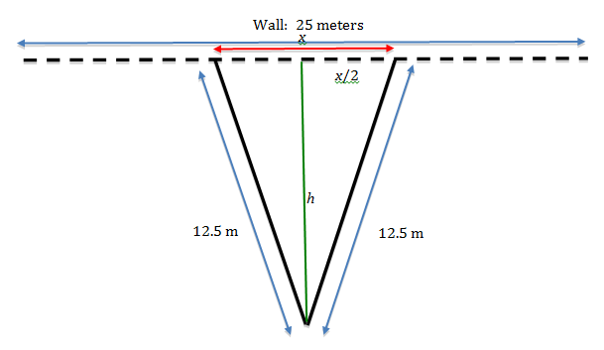

**Appendix C**

**Solution for Isosceles Triangle**

**.**



**.**

**.**





– [ (12.5)2 – (x/2)2 ] = x [ – (1/2)2x/4 ]

– (12.5)2 + (x/2)2 = – x2/4

x2/4 + (x/2)2 = (12.5)2

x2/4 +x2/4 = (12.5)2

2 (x2/4)= (12.5)2

x2/2= (12.5)2

 ≈ 17.68



**Solution for Equilateral Triangle**





**.**

**.**

**The ratio of Area of Isosceles Triangle to Area of Equilateral Triangle**

