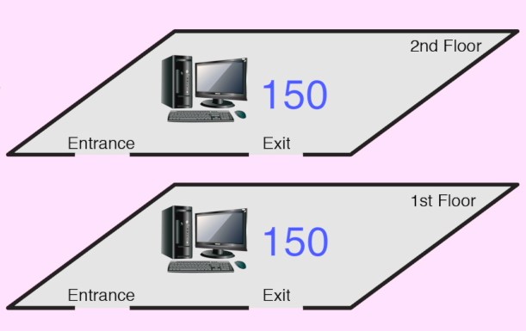

Instructions for Activity 7:

- 300 tables represent 300 computers
- 2 storey-restaurant represent 2 computer labs located at different floors of a 2 storey building.
- 150 computers are located in a computer lab at the first floor of the building while another 150 computers are placed in another computer lab at the second floor of the same building.

You will have to sketch your network design for 300 computers in a two-storey building. Teacher will provide notes on hybrid topology and you will be asked to come out with your own version of hybrid computer network topology. Design your network based on what you have learned e.g. linear bus, ring, star, and tree, notes given and the task given.

