Suggested Non-Quiz Assesment Activity for this Lesson

The map below shows the paths of some of the longest nonstop international flights. (Credit: http://www.tyranno.us/flight-times-map-from-london/ )

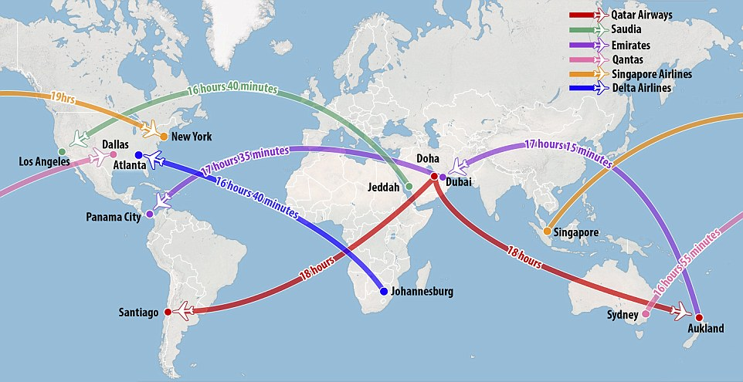

Using a Globe of Planet Earth and a rubber band,

- Try to identify minor arcs of the great circles used by airline pilots in navigating these routes. Does the flat map above accurately reflect these routes? Your comments about the match or mismatch?
- Using your Globe and your knowledge of certain distances on the Globe (in kilometers or miles), estimate the total distance travelled by airplanes undertaking each of these routes.
- Singapore Airlines has (or will have) the longest nonstop flights, from Singapore to New York City and return. 19 hours!! Carefully using your rubber band, try to identify the minor arc and major arc of the great circle that includes both Singapore and New York. From New York, in which direction should the pilot fly? From Singapore, in which direction should the pilot fly? Can you think of any reason (maybe not traditional mathematical geometry) why on occasion the pilot would choose to fly the major arc of the great circle rather than the minor arc? (In such a case, the round-trip flight would be a flight around the World!)

