Name:
Section:
Date:

Data Set 1

Rocket # | Set-Up  (Rocket Propellant) | Performance  (Time to React) | Rocket Design
Rocket #1 | Whole tablet + cold water | 0.57 seconds | 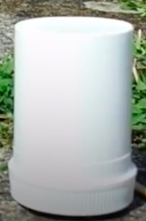
Rocket #2 | Whole tablet + hot water | 0.31 seconds | 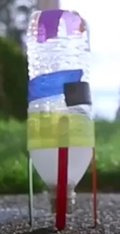

Data Set 2

Rocket # | Set-Up  (Rocket Propellant) | Performance  (Time to React) | Rocket Design
Rocket #3 | Broken tablet + cold water | 0.43 seconds | 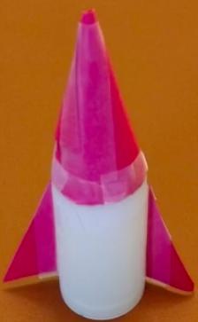
Rocket #4 | Crushed tablet + cold water | 0.21 seconds | 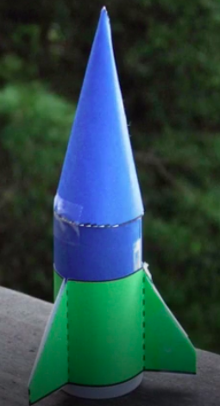

What patterns do you notice from the data? What is the evidence for your response?

Data Set 1:

Data Set 2:

In the boxes below, create models to explain the patterns you notice from the data:

Data Set 1:

Data Set 2:

With a partner: define “reaction rate” from your background knowledge and what you see in the data.

CER Paragraph:
Make a claim about one pattern you notice in your model and data sets. Support that claim with evidence from your data, and tie it all together with reasoning from your class work.

Claim: My optimal Rocket Propellant is _____.
Evidence: My evidence supports my claim because _____. From my data I can see that _____.
Reasoning: My evidence is connected to my claim because _____. (use a scientific principle that you’ve learned about for this part!)

Optimal Rocket Propellant
My optimal Rocket Propellant is…

These are four factors that affect reaction rate:
- Surface Area
- Temperature
- Pressure
- Concentration

- How did you address each of those factors in designing your optimal rocket propellant?

- Surface Area:
- Temperature:
- Pressure:
- Concentration:

- Why do you feel your group's rocket propellant design is the best? Refer to question 1 to write a CER with strong evidence.

Redefine “reaction rate” from your background knowledge and what you see in the video.

Analogous Scenario:

Here are three rocket propellant designs for NASA’s next launch. Building upon your experience which design do you feel will have the fastest reaction. Use evidence from the investigation to support your claim.

- Low pressure  - Cold temperature  - Solid Propellant | - Medium Pressure  - Warm temperature  - Liquid Propellant | - High pressure  - Hot temperature  - Gaseous Propellant

