The MIT-China OpenCourseWare Initiative

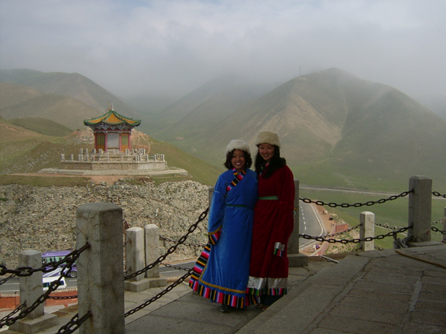
Qinghai Highlands

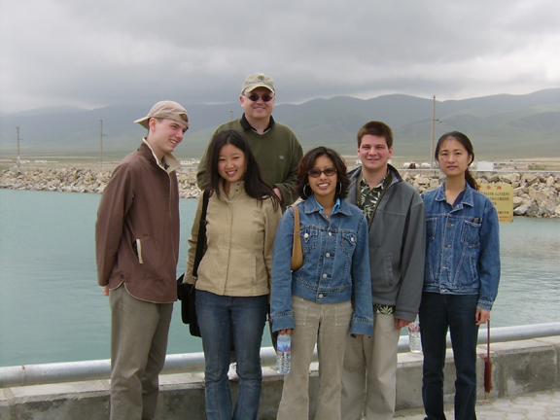
Qinghai Lake

The MIT International Science and Technology Initiatives (MISTI) Program, which has helped numerous high schools in China incorporate MIT course materials in their curricula in summer teaching programs, now plans to send teams of specially trained MIT students to work with rural area universities and secondary schools on OpenCourseWare projects. The goal of this broadened effort will be to share knowledge in two ways: by equipping MISTI interns to help faculty and students in Chinese schools to make use of OCW materials; and by promoting and reinforcing these efforts through workshops at MIT for China-based faculty and their US-based counterparts.

Our pilot OCW project took place this summer at Qinghai University. The MIT-China Program sent five MIT students to the Tibetan-Qinghai Plateau to work with Qinghai University faculty and students on MIT-OCW subjects in biotechnology, computer science, and environmental engineering. We identified Qinghai University through our partnership with Tsinghua University, which is working closely with Qinghai to help improve education standards in China’s western provinces.

MISTI China and Qinghai University
Xining, Qinghai Province

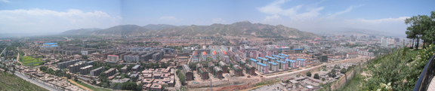
Xining

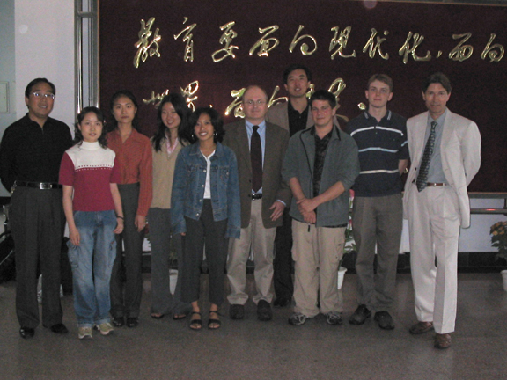

MIT Participants:

Yiqun Bai, B.S. candidate, Biology and Chemical Engineering, 2005
Siqi Chen, M.S. Biology, 2004
Peter Jeziorek, M.S. candidate, Mechanical Engineering, 2005
Salvatore Scaturro, B.S. Environmental Engineering, 2004
Michelle Tiu, B.S. Computer Science and Management, 2005

Julian Wheatley, Director, MIT-China Program
Sean Gilbert, Director of Intern Placement, MIT-China Program

Before departing to China in June, the five MIT students attended the MIT-China program’s spring-term internship preparatory seminar series, “Issues in Contemporary China,” which also included an MIT OpenCourseWare training session.

The MIT-China team’s teaching schedule was loosely based on the MIT model. Each week consisted of three lectures for each subject. Approximately 100 Qinghai University undergraduate students attended the lectures and two recitation days per week. Three recitations were taught for each subject. The recitation sections were designed to review material presented in lectures, provide extra time for the students to ask questions, and review sample homework problems. There was also one lab for each subject per week. The MIT students also added cultural presentations and seminars to the curriculum, including one lecture per week on aspects of American culture.

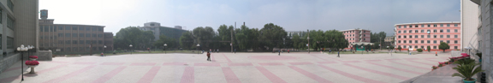
Qinghai University

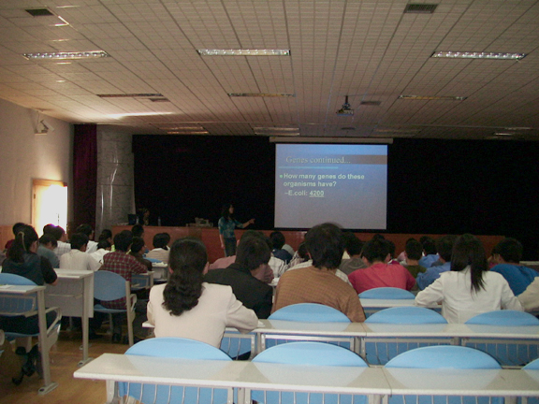
OCW Biology Lecture

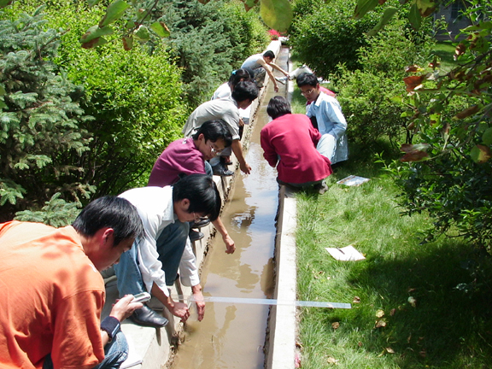
OCW Environmental Lab

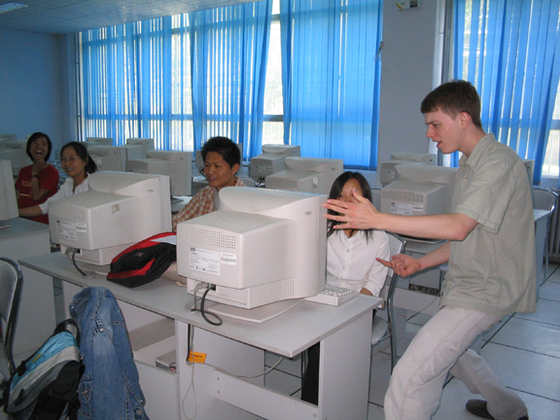
OCW Computer Lab

Future Plans

The MISTI-China OCW Initiative will be organized into three parts:

- MIT-based Chinese language and culture training and OpenCourseWare teaching seminars for MIT student interns.
- Placement of MIT students at rural Chinese universities and secondary schools for summer and up to one-year teaching internships.
- Chinese faculty visits to MIT to attend OpenCourseWare workshops, meet with MIT faculty, and develop networks in their fields.

The next phase of MIT-China OCW program development is to identify additional Chinese host institutions. We intend to send approximately 35 MIT students per year to teach OCW topics throughout China.

